

Project E-Bike

**Group 12**

**Group members**

Christopher Rumpf Computer Engineering

Victor Petrillo Computer Engineering

Carlos Curbelo Electrical Engineering

Alexander Gilbert Electrical Engineering

1.0 Executive Summary 7

2.0 Project Description 7

2.1 Project Motivation 7

2.2 Goals 8

2.3 Requirement Specifications 9

2.3.1 - Production Cost 9

2.3.2 – Weight 9

2.3.2.2 – Power 10

2.3.2 – Dimensions 10

2.3.3 – Speed 10

2.3.4 - Power 10

2.3.5 - Motor 10

2.3.6 - Microcontroller 11

2.3.7 - Speed Controller 11

2.4 Block Diagrams 11

2.4.1 High Level Overview 11

2.4.2 Controller Diagram 12

2.4.3 Logical State and Flow 12

2.5 Project Budget 13

2.6 Project Milestones 14

2.6.1 Tentative Senior Design 1 Milestones 14

2.6.2 Tentative Senior Design 2 Milestones 14

2.7 House of Quality 15

3.0 Research related to project and part selection 16

3.1 Batteries 17

3.1.1 Secondary Battery Types - Chemistry 18

3.1.1.1 Lithium-Ion Batteries 19

3.1.1.2 Nickel-Metal Hydride Batteries 19

3.1.1.3 Lead-Acid Batteries 20

3.1.1 Battery selection 21

3.2 Microcontroller (MCU) 23

3.2.1 Microcontroller Investigation 23

3.2.1.1 Texas Instruments - Mixed Signal Processing (MSP) 430 23

3.2.1.2 Microchip - Peripheral Interface Controller (PIC) 24

3.2.1.3 Atmel – AVR 24

3.2.1.4 Arm – Cortex-M 24

3.2.2 Microcontroller Firmware 25

3.2.3 Microcontroller Selection 25

3.3 Spatial Sensing 26

3.3.1 Accelerometer 26

3.3.2 Gyroscope 27

3.3.3 Magnetometer 27

3.3.4 Inertial Measurement Unit (IMU) 28

3.3.5 IMU Selection 28

3.4 Bluetooth Modules 29

3.4.1 - General Information 29

3.4.2 - Power Consumption/Output 30

3.4.3 – Communication Connection 31

3.4.4 Bluetooth Selection 31

3.5 Voltage Regulator 32

3.5.1 Linear Voltage Regulator with Low Dropout 32

3.5.2 Switching Regulators 33

3.5.3 Voltage Regulator Selection 33

3.6 Motors 33

3.6.1 AC Motor 33

3.6.2 DC Motors 35

3.6.2.1 Brushed DC Motor 36

3.6.2.2 Brushless DC Motor 37

3.6.2.2.1 Hub Motors 38

3.6.2.2.2 Geared Hub Motors 38

3.6.2.2.3 Direct Drive 39

3.6.2.2.4 Direct Drive vs. Geared Hub Motors 40

3.6.2.2.5 Hall Sensors 40

3.6.3 Motor Selection 42

3.7 Throttle Controls 44

3.7.1 - What is an E-Bike Throttle? 44

3.7.2 - Popular Throttle Types 44

3.7.3 - Consideration for Project 46

3.7.4 Throttle Selection 47

3.8 Torque arm 48

3.9 Brakes 48

3.9.1 Rim Brakes 49

3.9.2 Disc Brakes 50

3.9.3 Coaster Brakes 51

3.9.4 Drum Brakes 52

3.9.1 Brake selection 53

3.10 - App 55

3.10.1 App Design 60

3.11.1 Incandescent Bulbs 61

3.11.2 Light Emitting Diodes (LEDs) 61

3.10 Lights Selection 62

4.0 Related Standards and Design Constraints 63

4.1 Battery Standards/Regulations 64

4.1.1 Battery Standards 64

4.1.2 Battery Regulations 65

4.1.3 Motor Regulations 66

4.2 Bicycle Standards/Regulations 66

4.2.1 International Standards for Bicycles 66

4.2.2 Federal Regulations for Bicycles 66

4.3 Testing Certifications 67

4.3.1 ANSI/ESD S20.20-2021: Protection of Electrical and Electronic Parts 67

4.4 Economic Constraints and Time Constraints 68

4.5 Environmental and Health Constraints 68

5.0 Hardware and Software Design 69

5.1 Initial Design Architecture 69

5.2 Schematics 69

5.3 Software 72

5.3.1 MCU Software Design 72

5.3.2 Application Software Design 72

5.3.2.1 Bluetooth Connectivity Page 72

6. Project Prototype Construction 72

7. Project Prototype Testing Plan 72

8. Administrative Content 73

Work Cited 73

Figure 1: Hardware Diagram 11

Figure 2: Control states 12

Figure 3: House of Quality 15

Figure 4: Galvanic cell flows 16

Figure 5: Voltage output at temperature variances 17

Figure 6: NiMH discharge characteristics 19

Figure 7: Fully discharges lead-acid battery 20

Figure 8: Fully charged lead-acid battery 20

Figure 9: Battery pack chosen 21

Figure 10: Pitch, Roll, and Yaw example 26

Figure 11: BNOO85 block diagram 28

Figure 12: A Bluetooth module 29

Figure 13: Linear voltage regulator with low dropout 32

Figure 14: AC motor with VFD 34

Figure 15: Geared hub motor 38

Figure 16: Direct Drive Motor 39

Figure 17: Tranverse Section of a BLDC Motor 40

Figure 18: Bafang G310 Motor Schematic 41

Figure 19: Bafang G310 Motor Schematic 42

Figure 20: Picture of a half-twist throttle on an e-bike (copyright pending) 44

Figure 21: Picture of a full-twist throttle on an e-bike (copyright pending) 44

Figure 22: Picture of a thumb throttle on an e-bike (copyright pending) 45

Figure 23: Torque Arm (Copyright pending) 47

Figure 24: Single pivot-side-pull caliper brake 49

Figure 25: Hydraulic disc brake 50

Figure 26: Inside a coaster brake 51

[Figure 27: Internal of a drum brake 52](https://knightsucfedu39751-my.sharepoint.com/personal/alexgilbert_knights_ucf_edu/Documents/Senior%20Design%201/60_page.docx#_Toc131759095)

Figure 28: Dual pivot side-pull caliper brake 54

Figure 29: A pair of incandescent bulbs (Copyright pending) 60

Figure 30: A single, standalone LED (Copyright pending) 61

Figure 31: An LED strip (Copyright pending) 61

Table 1 : Project Budget 8

Table 2 : Project Weight 8

Table 3 : Power Usage 9

Table 4 : Project Dimensions 9

Table 5 : Budget Breakdown 12

Table 6 : SD1 Milestones 13

Table 7 : SD2 Milestones 14

Table 8: Battery Options Comparison 21

Table 9 : MCU Requirements 24

Table 10 : MCU possibilities 25

Table 11: Different IMU Chips 27

Table 12 : Bluetooth Module Comparison 30

Table 13: Types of AC Motors 33

Table 14 : Types of DC Motors 35

Table 15: Brush vs Brushless DC Motor 37

Table 16 : Comparison of Motor types 39

Table 17: Motor Design Specifications 42

Table 18 : Types of Throttle 46

Table 19 : Comparing Types of Brakes 53

Table 20 : Comparison Table of Browser Web Apps 59

Table 21: Lightning Comparison 61

Table 22: State of Florida Ebike Class Regulations 66

# 1.0 Executive Summary

Very recently there are large pushes for people to begin switching from combustion engines to electric cars. Many state it’s better for the environment in a time when the world is slowly heating. However, there are many people who don’t have to money or the need for a large vehicle in order to get places or to move different items around.

Instead of using vehicles for transportation or to haul small items such as groceries instead we propose using electric bicycles (e-bike). These will not work for some Americans because we our infrastructure is designed around having automobiles. In other parts of the world, however, like for example in Europe the distance between buildings are not as far apart as here so a bicycle would make more sense there.

This report will detail the steps taken to design and plan the ability to change a bike to an electric version which will enable faster travel. Firstly, will be the outline of the background of the different technology that is planned to be used in the project. This includes problems that used to be present, problems that are happening now, and possible problems in the future.

Afterwards, we will state the goals we wish to accomplish with this project and along with those goals will be the objectives, requirements, and constraints that we will need to accomplish to achieve our goals. Then will be the design layout of the project which will include the hardware and the software. Finally, we will state the reasons as to why we decided to go with the items we did and not others along with problems we found that may need to be fixed in later versions.

# 2.0 Project Description

The goal of the project is to create an e-bike conversion kit that will allow usage through an app connected via Bluetooth. The e-bike will include a cruise control that will be activated on the app along with having battery level gauge sent to your phone. This will allow easy access to the e-bike’s modes and status.

## 2.1 Project Motivation

People need to use automobiles to go nearly everywhere nowadays, needing to go to school, work, or the grocery store. Everyone uses cars because everything is far from each other and the use of a bike either takes too long or there is not enough space. An e-bike gives more freedom to the user. Compared to electric vehicles, an e-bike is less expensive, and a better alternative means of transportation in a city. The inexpensiveness of an e-bike compared to a vehicle allows more users compared to the cost of an automobile.

## 2.2 Goals

## 

Goals for this project include, but are not limited to:

Fundamentals:

* Being able to use the bike without pedaling.
* Providing enough speed to maintain balance.
  + (Hopefully not fall off from going too slow)
  + The amount depends on the environment.
* Engineering Goals:
  + App
  + Throttle control for speed
  + Cruise control
  + Ensure a constant speed that the user decides.

Stretch/advanced goals that are not currently in the active scope, but can be worked on after main goals are met:

* Regenerative braking will help with the distance the electric bike will be able to go.
  + Energy generated from braking can be used to charge battery.
  + The amount depends on the environment.
  + There will need to be an analysis of the weight added to the energy given back.
* Building an application that is paired via Bluetooth to send and receive information to and from the bike.
  + Such information will include, but is not limited to:
    - Battery level
    - Time spent on the bike for a specific event.
    - Current speed
* Create a lighting system that would allow riders to always ride safely in the day and night.
* Providing an assist mode.
  + This mode will help you when pedaling.
    - For example, when going up a hill the force required to continue going up the hill increases.
    - When using assist mode, the motor will make up for the increase needed to go up the hill.

## 2.3 Requirement Specifications

These are the design specifications. We plan to follow these closely as we design and create our project. Though these specifications are subject to change at any point during the project, they will aid us in structuring the design and guide us in the right direction for success.

## - Production Cost

* We are making efforts to keep the cost of all the components to under 1000 dollars.

|  |  |
| --- | --- |
| Item | Cost |
| Bicycle | Free |
| Power | $329 |
| Motor | $60 |
| Bluetooth | $8 |
| PCB | TBD |
| MCU | $38.3 |
| Throttle | $15 |

Table : Project Budget

### 2.3.2 – Weight

* The total weight of the project is going to be 35 lbs. or 15.88 kg.

|  |  |
| --- | --- |
| Item | Weight |
| Bicycle | 20 lbs or 9 kg |
| Motor | 2.5 kg |
| Power | 4.74 Kg or 10.45 lbs |
| Bluetooth Module | TBA |
| Brakes | TBA |
| Throttle | TBA |

Table : Project Weight

#### 2.3.2.2 – Power

* Batteries that are about 500-watt hours can weigh up to 6 – 8 lbs. or 2.7 - 3.6 kg.
* The battery will last around 2 hours

|  |  |
| --- | --- |
| Item | Power usage |
| Bicycle | None |
| Motor | 250 – 350 Watt |
| PCB | TBD |
| Bluetooth | 3 V |
| Throttle | None |

Table : Power Usage

### – Dimensions

|  |  |
| --- | --- |
| Tires | 28x1.95 |
| Motor | 10 x 2 x 2 (in) |
| Power | 365 x 90 x 110 mm |
| PCB | TBD |
| Throttle | TBD |
| Bluetooth | 12.9 x 15 x 2.2 mm |

Table : Project Dimensions

### 2.3.3 – Speed

* At least walking speed (2-4 miles per hour)
* At most: electric bike Class 2 standards of 20 miles per hour.

## 2.3.4 - Power

* 250-350 Watts
* Rear mounted
* Rechargeable Lithium Li-ion

### 2.3.5 - Motor

* A brushless motor with sensors will be used for efficient operation.
* We are trying to have the motor carry someone of about 250 lbs.
* Hub Motor

## 2.3.6 - Microcontroller

* Different sensor input detections (throttle, battery, fuel)
* Output comparison component
* Control of the brushless motor

### 2.3.7 - Speed Controller

* Since in our design, we are using a brushless motor with sensors, we have the option of using either a sensor or sensor less speed controller.
* The use of a PID controller will be what we use for the speed controller.

## 2.4 Block Diagrams

### 2.4.1 High Level Overview

This diagram covers the main pieces of the bike as individual components. A central control module will use electrical power that can also drive the bike motor. Peripheral inputs, such as throttle control, brake levers, and mode selector also feeds signals into the controller to determine the bike’s behavior. The controller also outputs data and information to an app that can be used as a display or log that data.

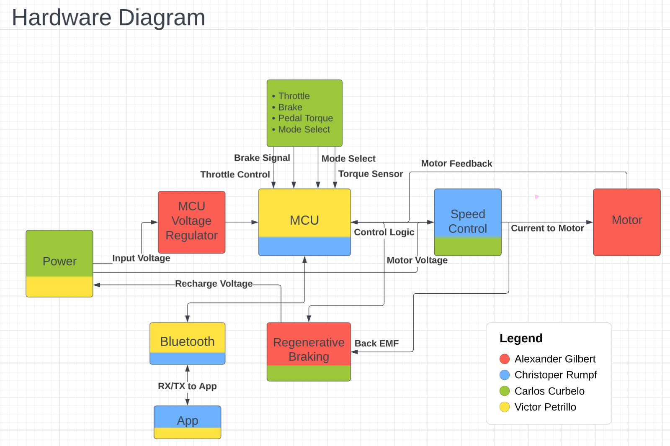

Figure : Hardware Diagram

### 2.4.2 Controller Diagram

Within the control board the main logic of the bike will be a microcontroller (MCU) that will take in all the signals and data. The MCU will be powered by the bike’s main input power using a voltage regulating circuit. Motor control is done via a speed control circuit. The MCU will use feedback from the motor to regulate speed based on the bike’s signals and feedback. Also, a regenerative braking circuit will be able to take the counter-electromotive force (back EMF) from the motor to recharge the battery. Any data that is logged, displayed, or input signals from the app will communicate to the MCU via a Bluetooth module.

### 2.4.3 Logical State and Flow

This state diagram shows the logical flow of the bike’s MCU. When initially powered on the bike would be in an idle position where the bike can then be used as a bike with no electrical input or change into a powered mode using the motor. Using the throttle would put the bike in a driven state where the bike is powered by the motor regardless of the rider pedaling. An assist state is also available where the motor is used only to help the rider pedal such as making going up a hill require less work. When the brake lever is pulled, the controller will attempt to recharge the battery using back EMF from the motor.

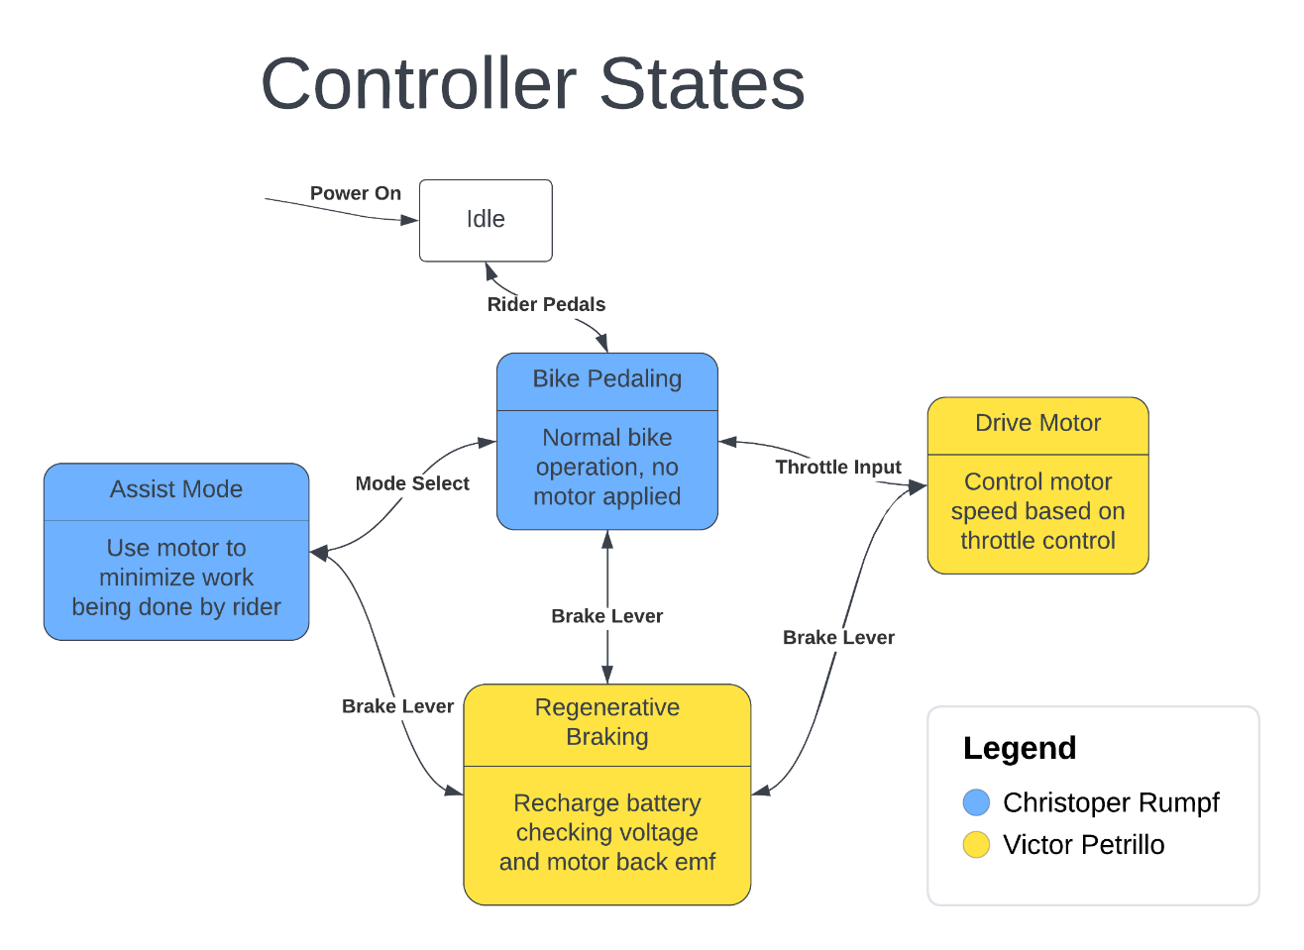

Figure : Control states

## 2.5 Project Budget

|  |  |
| --- | --- |
| **Item** | **Estimated Price** |
| Motor (1 unit) | $200 |
| PCB (3 – 5 units) | $20 |
| Batteries (1 unit) | $250 |
| Sensors | $50 |
| Circuit components | $100 |
| **Forecasted Total** | $620 |

Table : Budget Breakdown

## 2.6 Project Milestones

These are the milestones set for our group as directed for both Senior Design 1 and Senior Design 2. Completion of each milestone is subject to change as each due date passes. Any updated dates will be changed in the updated version of the document.

### 2.6.1 Tentative Senior Design 1 Milestones



Table : SD1 Milestones

### 2.6.2 Tentative Senior Design 2 Milestones

|  |  |
| --- | --- |
| **Dates** | **Milestone** |
| Week 1 (5/14/23-5/20/23) | Build |
| Week 2 (5/21/23-5/27/23) | Build |
| Week 3 (5/28/23-6/3/23) | Build |
| Week 4 (6/4/23-6/10/23) | Building / Testing |
| Week 5 (6/11/23-6/17/23) | Testing |
| Week 6 (6/18/23-6/24/23) | Middle Term Demo |
| Week 7 (6/25/23-7/1/23) | Make Changes |
| Week 8 (7/2/23-7/8/23) | Conference Paper |
| Week 9 (7/9/23-7/15/23) | Build & Edit Paper |
| Week 10 (7/16/23-7/22/23) | Test & Edit Paper |
| Week 11 (7/23/23-7/29/23) | Final Presentation and Demo |
| Week 12 (7/30/23-8/5/23) | Senior Design Web Exit Interview |

Table : SD2 Milestones

## 2.7 House of Quality

The most important engineering criteria and the critical marketing requirements will be systematically laid out in the house of quality that we created. This product needs to meet several important criteria in order to be marketable. We identified six areas where we would like to meet clients after carefully examining the market of the product. Regarding how we will meet the marketing needs, engineering requirements are the key focus. To pique consumer attention, we must address six crucial components of engineering needs.

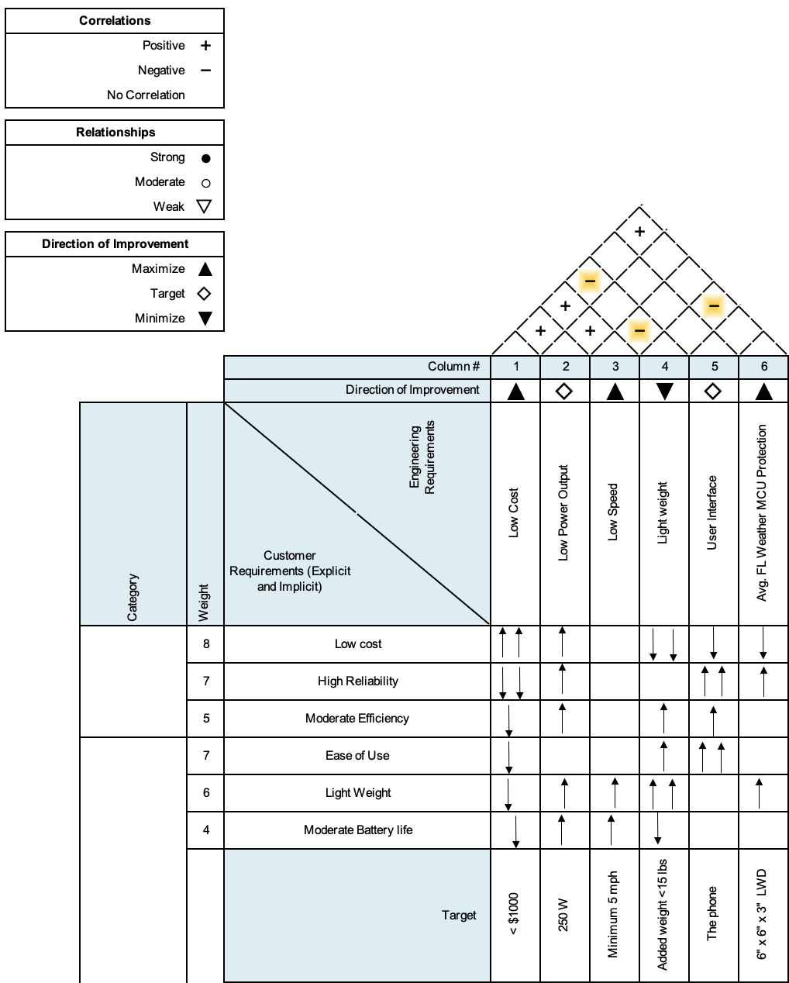

Figure : House of Quality

Keeping the development cost low for the group typically has a negative correlation with certain customer requirements. Having a lower power output correlates positively with most of the customer requirements because having a lower power output can result in increased longevity and efficiency, a lighter weight, and a lower cost. The speed of the bike doesn’t correlate much with the customer requirements at all, other than how heavy the bike is and how much battery life is left.

# 3.0 Research related to project and part selection

In the divide and conqueror document the group did a preliminary block diagram for what we believe will be needed for the entirety of the project. An updated and complete version of a hardware block diagram will be added to this document as more information is learned and understood throughout the length of this project. The subsections below will contain all technology that was found and is relatable to the completion of this project. There will also be product investigation and with that a pro and con chart for the different product available that may be used in the future.

## 3.1 Batteries

There are primary and secondary batteries. The former is a single use while the latter is the more common type we see where the battery is rechargeable. The reason for the differences is that the electrode materials are made in a way that is not reversable while the electrodes in a secondary battery are reversed when applying an electric current. In the case of this project we will need to use a secondary type so the battery on the e-bike will be able to be reused.

Batteries transfer charge by using a process called oxidation and reduction. This was first discovered by an Italian named Alessandro Volta using copper and zinc separated by a saltwater solution. Oxidation is when a substance loses electrons (the zinc from the previous example) and transfers over to the substance gaining electrons which is called reduction (the copper). This process is one time use for primary batteries where the oxidation and reduction process is not reversable. In secondary batteries, however, it is reversable but only for a certain number of charge cycles. This is accomplished by transferring the electrons back to the metal so the oxidation process can occur another time. Every time this process occurs there may be irregularities in the metal which keep the metal from oxidizing correctly. This may reduce the max charge or even kill the battery outright and no longer be able to hold a charge. An anion is a negatively charged ion.

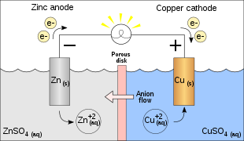

Figure : Galvanic cell flows

Batteries are affected by a few different characteristics. One is temperature. There are a few other characteristics such as the material used for a battery. This is primarily a concern for lithium-ion batteries which have a few different chemical makeups as opposed to the other secondary batteries that will be spoken of in 3.1.1 Secondary battery types – chemistry.

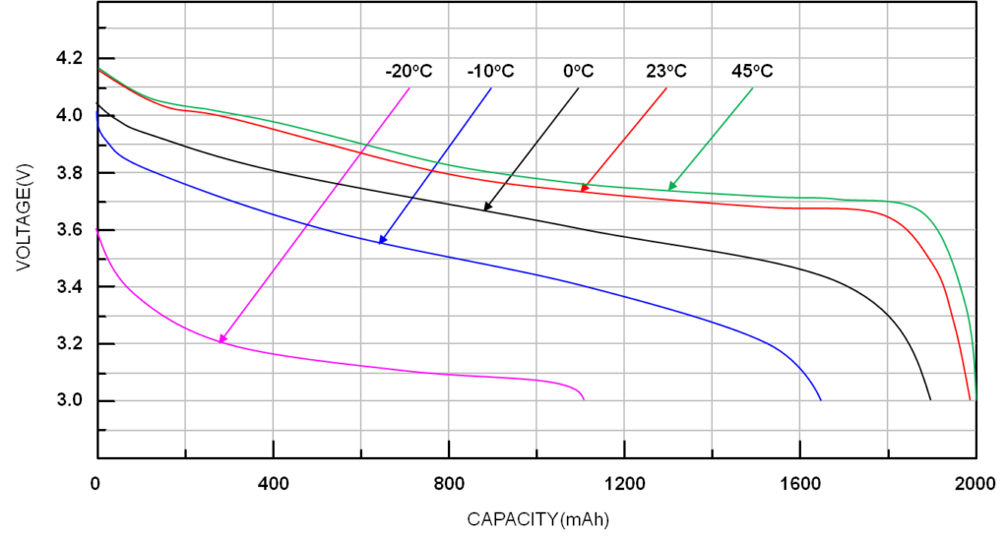

Figure : Voltage output at temperature variances

As can be seen above the voltage output of a battery decreases as temperature decreases. This means there is a nominal temperature for a battery to operate at, however, seeing as we are in Florida and the specifications for the project call for normal Florida weather there is no need to consider any large changes in output voltage.

Size has the main effect of changing the capacity of a battery (measured in amp hours Ah). This is a measure of how long a battery can last for one hour when pulling at that rate. An example of this happening can be seen in the figure under 3.1.1.2 Nickel-Metal Hydride batteries.

### 3.1.1 Secondary Battery Types - Chemistry

A basic visual for a secondary battery can be seen in the previous figure above in section 3.1 Batteries. There are many different chemistries for secondary batteries, however, there are specific chemistry types that are more well known than others. There are three main battery chemistries that are used today, one being lithium-ion, these are found in portable devices such as phones, and laptops. The second is a lead-acid battery, these are found in combustion engine vehicles, more recently, however, in electric vehicles the battery chemistry is lithium-ion. The third type of battery is Nickel-Metal Hydride (NiMH), which is found in rechargeable batteries from companies such as Energizer.

### 3.1.1.1 Lithium-Ion Batteries

Having a battery being Lithium-Ion is very broad because the electrodes have a few different options in regard to technology with different benefits and main applications. The anode is fairly consistent using some form of carbon. The cathodes are made with a metal oxide that always includes lithium. The most popular chemistries contain cobalt because of the stability of the element when reducing. However, cobalt is an expensive element along with nickel (which can be seen in other chemistries) so other alternatives are being looked at actively as a replacement. For example, a cathode of lithium iron phosphate (LFP; LiCoO2) was discovered by Arumugam Manthiram and John B Goodenough and could be used as a cathode.

These batteries are considered to be the best secondary battery available because of a few factors. There are three main reasons to this. The first is the higher specific energy (other than LFP) of the battery being around 460 kJ/kg while the next most common would be the NiMH battery being at 360 kJ/kg. The Li-ion battery also has low rate of self-discharge from 0.35% to 2.5% depending on state of charge with an output voltage of approximately 3.6 volts. There are safety concerns for this battery that will be further explored in section 4.1.

### 3.1.1.2 Nickel-Metal Hydride Batteries

This chemistry is most often found in single celled rechargeable batteries used in video game controllers or places where a AA and are used as a replacement for alkaline batteries because alkaline batteries are nominal at 1.6 volts while NiMH operate nominally at 1.2 volts. The discharge rate is dependent on if the NiMH battery is a low self-discharge version at a cost of approximately 25% capacity. The discharge is 13.9% to 70.6% while the slow discharge rate is 0.08% to 2.9% which is comparable to Li-ion but at a lower energy density. Below is a discharge curve for an EnergizerTM NH15-2300 rechargeable battery.

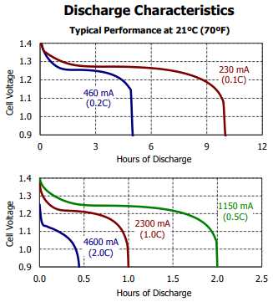

Figure : NiMH discharge characteristics

As can be seen in the above figure, cell voltage drops dramatically in the first 10 minutes of discharge but then depending on rate of discharge can be fairly consistent until a point in time when the battery no longer is capable of oxidizing and then the cell voltage immediately drops to 0.9 volts.

### 3.1.1.3 Lead-Acid Batteries

Normally used in vehicle operations because of the high surge current needed for start up a motor. However, these have a high discharge rate and few battery discharge cycles comparatively to lithium ion and NiMH. They are also very cheap comparatively so they can be used on other applications as well.

The chemistry consists of having a lead plate on both sides with a sulfuric acid solution in-between. The acid solution changes depending on if the battery is charged or discharges fully. Below is the figure for a fully discharged plate.

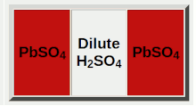

Figure : Fully discharges lead-acid battery

As seen in the figure above the two plates are the same being lead sulfate and the electrolyte becomes primarily water because the electrolyte becomes dilutes while discharging. Now will be the fully charged state of a lead-acid battery.

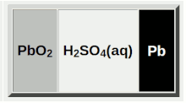

Figure : Fully charged lead-acid battery

In this case the negative plate is the lead while the positive is the lead dioxide and these plates are separated by a concentrated sulfuric acid.

## 3.1.1 Battery selection

Currently most options consist of Lithium-Ion batteries because of their low discharge rate, higher voltage output, and high energy density. Therefore, the market is saturated with lithium-ion batteries and the only other option would be a set of nickel-metal hydride cells in series to get the needed voltage and has a higher rate of discharge compared to a Lead-acid which has fewer charge cycles which would not work for this application. This would require more work than is in the scope of this project so will not be done and will instead use the readily available lithium-ion batteries. Below will be a comparison of the two battery chemistry types that will be used and the other option that could be used if there was a more market availability.

Seeing as the motor (in 3.6) has a power maximum of 700 watts, but is expected to be 250-350 watts, a 36-volt battery with a limit of 9.5 amps would produce 342 watts to attempt to stay under the max nominal power. If the battery outputs at 24 volts we would keep the amperage at around 14 amps for a wattage of 336 which would be below the 350 watts. We limit the amps to ensure the e-bike does not go above the speed that would make the e-bike a class three.

|  |  |  |
| --- | --- | --- |
|  | **Lithium Ion** | **NiMH** |
| Market availability | High | Zero |
| Discharge rate | Very low | Has a range from very low to low |
| Voltage | Around 3.6 | Around 1.2 |
| Cost | Very high | Medium |
| Energy density | Very high | Medium |

Table : Battery Options Comparison

From the table of differences above a lithium-ion battery pack is the only choice though would be the best choice given how this battery will be used. It will need to be reliable with a low discharge rate while idle and not in use. The energy density will also help with any distance issues that may have arisen if the NiMH chemistry had been used.

The battery we could use is the *36v 20Ah Unit Pack Power e-bike battery*. This would give us the voltage needed to power the motor and would be able to run the motor continuously for around two hours assuming we limit the amperage to the 9.5 amps that was calculated earlier. The battery will allow the motor to get the necessary power to not only run for two hours but will also have the capability to allow the motor to go up a slight incline while maintaining a higher speed.

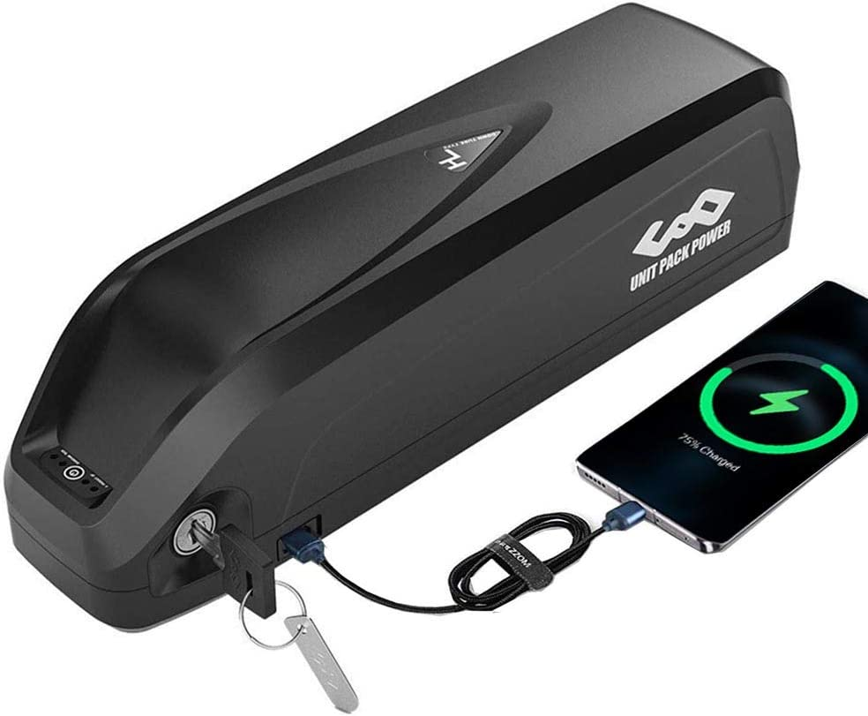

Figure : Battery pack chosen

The max current discharge for this item is 25A which is higher than the current we plan to take from the battery pack and also give us room to also ensure that the other components can be powered. The other components include the microcontroller which will allow us to run the Bluetooth module for the app.

The other option is much cheaper but if something breaks with the item it has a much longer return time of around two months. It is essentially the same thing.

## 3.2 Microcontroller (MCU)

A microcontroller (MCU) is a small computer that is built into an integrated circuit (IC). MCUs are used in many applications from appliances, robotics, vehicles, and more. An MCU will contain a central processing unit (CPU), random-access memory (RAM), read-only memory (ROM), and inputs and outputs (I/O) all on a single IC. Not to be confused with a microprocessor, which is a single IC that contains a CPU with none of the peripherals a MCU will contain: RAM, ROM, or I/O. MCUs can be designed for large applications with high CPU word sizes, 64-bit or 32-bit, and high clock speeds, small 4-bit or 8-bit sizes, and low clock speeds; or any combination in-between. They also have many different built in serial interfaces such as: recommended standard 232 (RS-232), inter-integrated circuit (I2C), serial peripheral interface (SPI), and controller area network (CAN). These serial interfaces can allow a MCU to communicate with other MCUs or sensors that support those protocols. Along with serial interfaces there are many peripherals that can be added: analog-to-digital converters (ADC), digital-to-analog converters (DAC), timers, pulse-width modulation (PWM) generators, and digital signal processing (DSP). Taking all these MCU design options into consideration the e-bike will use a single MCU with enough I/O and peripherals to do the necessary control and communication for the project.

### 3.2.1 Microcontroller Investigation

These next sections will cover an investigation of different manufacturers of MCUs and their products. Also, the MCU programming environments for development and debugging will be explored. The MCUs in consideration are not meant to be a complete market comparison but just a small subset of what is known, available, and easy to use.

### 3.2.1.1 Texas Instruments - Mixed Signal Processing (MSP) 430

Texas Instruments (TI) makes multiple models of MCUs but the one focused on here is the MSP430. The MSP430 is a 16-bit MCU that focuses on low power usage. The top speed is 25 MHz and has multiple peripherals such as PWM modules, I2C, SPI, and ADCs. Programming the MSP430 is done in the C/C++ or assembly language using TI’s Code Composer Studio (CCS).

### 3.2.1.2 Microchip - Peripheral Interface Controller (PIC)

Microchip makes 8-bit, 16-bit, 32-bit, and dsPIC MCUs. Some of the higher end MCUs can reach speeds of 120 MHz or have 49 to 78 I/O pins. Certain models have built-in peripherals such as integrated Motor Control PWM and a Motor Encoder Interface which would help directly with the motor control portion of the project. PIC microcontrollers can be programmed using Microchip’s PICkit which is a hardware serial tool for programming and debugging. Microchip also provides an integrated development environment (IDE) called MPLAB X as a tool for writing code in C.

### 3.2.1.3 Atmel – AVR

Atmel AVR is a family of microcontrollers designed and manufactured by Atmel Corporation, now owned by Microchip. The AVR microcontrollers are usually 8-bit. AVR microcontrollers are typically programmed using C and Atmel Studio (IDE). The AVR microcontroller is also the microcontroller of choice for the Arduino platform. Arduino is both the hardware and software meant to make building and programming microcontrollers easily accessible. Programming in Arduino is done using the Arduino Programming Language which is like C and C++.

### 3.2.1.4 Arm – Cortex-M

The company Arm designs and licenses a family of microcontrollers they also call ARM. The acronym used to stand for Advanced RISC Machine, with RISC being reduced instruction set computer. Arm does not manufacture any of their designs and instead licenses the architecture to other companies to build and add any peripherals. The main groups of Arm microcontrollers are Cortex M, R, and A. The groups have different applications with Cortex-A being application processes and would be used for operating systems like on Android or IOS phones and more. Cortex-R are for real-time applications and high performance, most are used in low level systems like hard drive controllers and airbags in vehicles. Finally, Cortex-M processors are more general purpose but still can be high performance and low power.

The focus for this project will be on the Cortex-M series. Because of the nature of the way Arm microcontrollers are manufactured it can be difficult to narrow down one way to program and use. There is one way to program Arm microcontrollers using Joint Test Action Group (JTAG) standard. JTAG is an industry standard for programming and connector layout. Also, Arm can be used with Arduino, Java, C, and many other languages.

### 3.2.2 Microcontroller Firmware

The code to be written to the MCU is called firmware, and there are two main structures: super-loop and real-time operating system (RTOS). The super-loop structure is very simple, after initial setup an infinite loop will loop through all of the tasks and functions the MCU needs to perform. This can be good for a few simple tasks but some steps in the loop can take longer than others causing slower than expected performance. On the other hand, RTOS has a scheduler that can allow tasks to be performed almost concurrently. Each task can be given a specific time to run and the scheduler will switch between them and make sure one does not block other tasks from running. For our e-bike application we will have a few main tasks always running: Bluetooth communication, polling sensor data, motor control, and other miscellaneous tasks such as lights and brakes. Because of this we will try to use an MCU that can support an RTOS due to all the functions we need to run. All of the MCUs previously discussed can support an RTOS with some being better than others.

### 3.2.3 Microcontroller Selection

There are many kinds of microcontrollers for different cases with diverse programming options. The expected MCU pins and peripheral requirements are listed in the table below. Speed will also need to be taken into consideration since controlling the motor and sending different communication protocols simultaneously could cause slowdown and unexpected behavior.

|  |  |  |
| --- | --- | --- |
| **Function** | **Number of pins** | **Protocol or Peripheral** |
| Motor driver | 6 | PWM |
| Motor sense/feedback | 3 | Interrupts |
| Bluetooth module | 2 | Serial (RS-232) |
| Throttle | 1 | Analog/Digital |
| Brakes (Front and Rear) | 2 | Analog/Digital |
| Battery monitor | 1 | Analog |
| IMU | 2 | I2C |
| Lights | 5 | GPIO |

Table : MCU Requirements

Based on the investigation the list of possible MCUs are shown in the table below. These were selected as options based on availability, programming interface, and use case.

|  |  |  |  |
| --- | --- | --- | --- |
| **MCU company** | **MCU** | **Programming Interface** | **Programming Language** |
| TI | MSP 430 | JTAG | C |
| Microchip | dsPIC | PICkit | C |
| Atmel | AVR | JTAG / Arduino | C / Arduino |
| ARM | Cortex-M | JTAG | C |

Table : MCU possibilities

STMicroelectronics makes a family of ARM MCUs called STM32 which look like a good choice and are available. The F4 series of STM32s is ARM Cortex-M4 with high speed and many peripherals that can work for our project, specifically an advanced timer feature that can output multiple PWM signals for motor control. The smallest STM32F4 comes in a low-profile quad flat package (LQFP) with 64 pins, specifically called *STM32F405RGT6* this will be our MCU for the e-bike. Also, Microchip’s *dsPIC33EV* is a good choice since it has built in support for BLDC motors and multiple PWM channels. At the time of this writing some dsPICs are difficult to find in stock and will mainly be used as an alternative the STM32.

## 3.3 Spatial Sensing

As an added safety feature the bike will be equipped with a sensor to determine its position and orientation in space. Since the bike controller is all being designed and built, some sensing unit will be needed. This can be done in a multitude of ways from vision implementations to proximity detection. Using vision would require a processor with large computing power and unrealistic for the goal of this project. On the other hand, using a proximity detector can be useful but has poor tolerances and might require multiple sensors to detect all necessary angles. The goal will be to have an added sensor that could detect impacts, orientation and potentially road gradients, and other operational data.

### 3.3.1 Accelerometer

An accelerometer is a sensor that measures an object’s acceleration. Accelerometers can be made in different ways from using a small, microscopic mass that moves inside the sensor called a micro-electromechanical system (MEMS). Another way is variable capacitive (VC) where a mass is between two plates and the change in capacitance is related to its acceleration. Also, piezoelectric which uses a piece of piezoelectric material to convert motion into an electrical signal. Depending on configuration, sensors can be setup for 1, 2, or 3 axes in space. Because of advances in manufacturing and parts becoming smaller, and more space effective, 3 axes sensors are common. The use of an accelerometer on the bike would be to sense sudden changes in acceleration or large spikes which would indicate an impact. In the event of an impact the bike could shut down or turn the motor off to prevent further damage.

### 3.3.2 Gyroscope

A gyroscope measures an object’s angular velocity, which is its rotation about an axis. Like accelerometers, gyroscopes can also be MEMS or piezoelectric. The 3 axes in relation to an object's center of gravity have a name: pitch, roll, and yaw. Although these names are usually associated with aircraft the same names and applications can be applied to the bike. For use on the bike the absolute angle of the bike can be detected to see if the bike is falling over or is flipped. Depending on if it is possible, the gradient angle of the road the bike is on could possibly be detected which can be some helpful data to the rider.

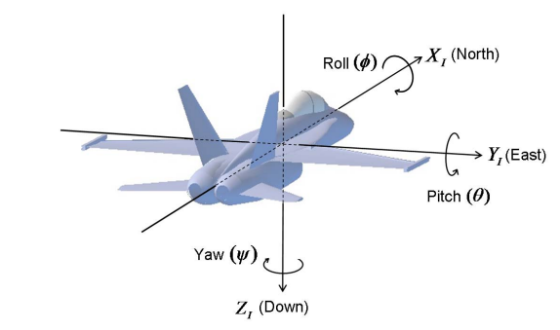

Figure : Pitch, Roll, and Yaw example

### 3.3.3 Magnetometer

A magnetometer senses magnetic fields; a compass is a common application. Magnetometers have many applications in navigation, environment monitoring, and even medical devices. Our purpose in using a magnetometer would be for heading data. Giving the rider a readout of which cardinal direction they are moving is useful in urban and rural environments.

### 3.3.4 Inertial Measurement Unit (IMU)

All the above sensors can be packed into one sensor called an inertial measurement unit (IMU). The IMU can be used to measure a bodies’ orientation and motion in space. Although an IMU is one unit it is usually made of individual sensors: accelerometer, gyroscope, and magnetometer. Not all are required; an accelerometer and gyroscope are used with a magnetometer being optional. We can use an IMU to sense all our criteria such as sudden acceleration spikes, angular data in case the bike were to fall, and use the magnetometer as a compass.

### 3.3.5 IMU Selection

There are many IMUs on the market. A 9 degree of freedom (DOF) IMU with 3 axes accelerometer, gyroscope, and magnetometer are available and widespread on the market. Another thing to consider is converting the data from the IMU into useable information. The process to do this is outside the scope of this project. Fortunately, there exist IMUs with built-in microcontrollers that can do the processing on-chip and offload that to the IMU instead of the main MCU. The main MCU can then get relevant data from the IMU via interrupts or polling.

|  |  |
| --- | --- |
| **IMU** | **Features** |
| BNO055 | FusionLib software for absolute position |
| BNO085 | SH-2 firmware with MotionEdge |
| ICM-20948 | Digital Motion Processor |
| MPU-9250 | Digital Motion Processor |

Table : Different IMU Chips

Some of the listed IMUs are reaching end-of-life (EOL) and are no longer in production. Others using the integrated Digital Motion Processor (DMP) have difficult documentation. The IMU chosen is the *BNO085* which is built on the same hardware as the BNO055 but with an updated firmware for better performance.

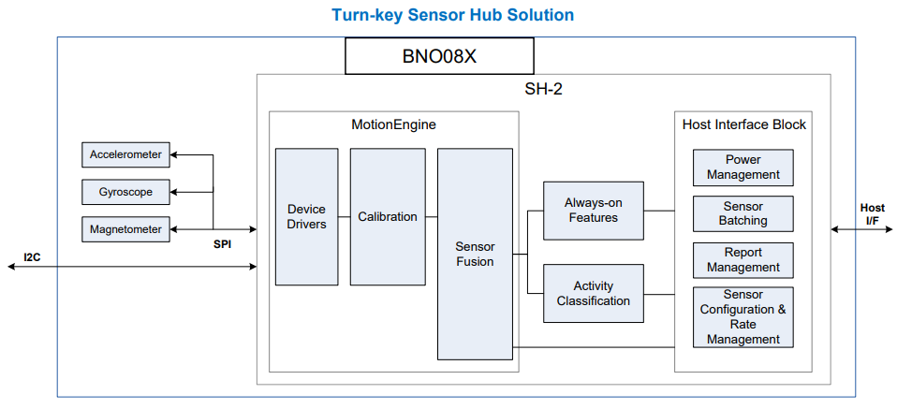

Figure : BNOO85 block diagram

## 3.4 Bluetooth Modules

For this section we are looking into Bluetooth modules. Bluetooth is a technology that uses radio waves to transmit high-data information across short distances, as opposed to the small-data, long-distance nature of most radio waves used today.

We will discuss some of the features that we deemed necessary for our design specifications. The group is planning on utilizing Bluetooth technology by integrating a Bluetooth module into our main PCB, and then engineering it to transmit and receive information from a connected smartphone running our custom smartphone application.

### 3.4.1 - General Information

Bluetooth modules are exactly what the name may suggest: finished hardware components that, when integrated with other technology, can enable the use of Bluetooth within whatever the module is fitted into. Rather than having to come up with a way to implement this technology by making our own circuit, Bluetooth modules simplify this process. The group’s goal is to achieve a Bluetooth connection with a smartphone and its respective application; *how* this goal is achieved is not being considered.

According to mokoblue.com, Bluetooth modules have a maximum communication range of around 100 meters (about the length of a football field). This range classifies Bluetooth connections as short-range communications. This is an ideal specification for the group’s application, since a communication technology is required that can send high amounts of data over a short distance; it is assumed that the connected smartphone would be carried by the operator of the e-bike.

When selecting a Bluetooth module to use for our project, there are multiple things to consider. Included in these things are the Bluetooth module’s application and transmission distance, which were already considered previously; both the application and transmission distance are compatible with almost all Bluetooth modules. Among other things to consider are power consumption, technical documentation/support, and, since we live in the wonderfully moist state of Florida, we must also consider the moisture sensitivity of these modules.

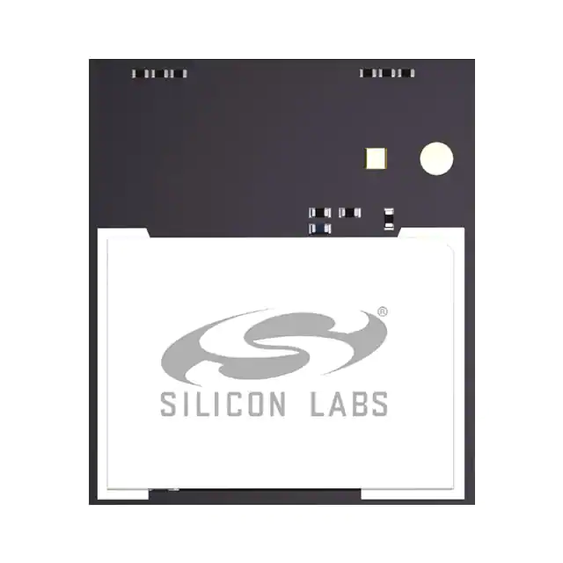

Figure : A Bluetooth module

### 3.4.2 - Power Consumption/Output

Power consumption and power output are both incredibly important specifications to consider when selecting a Bluetooth module. Having the incorrect power consumption information could mean that your hardware will fail; parts could not function properly because they’re not getting enough power, or they can become damaged after receiving too much power.

The group is considering both specifications for the project. When considering power consumption, having a smaller power consumption will be ideal. The e-bike is just that: an electric bicycle. It is dependent on the electricity that can be provided by the battery we select. Having components that use less power where they are able will be invaluable to the longevity of the e-bike, both in the short term and long.

The output (transmit) power of the module is measured in dBm (decibel meters). The units scale similarly to decibels, with increases in the units being exponential rather than linear. The modules listed after performing a quick search on Mouser Electronics reveal that modules commonly operate within the +10 to +20 dBm range. In our case, as previously mentioned, the range will not be very far; the operator of the e-bike will be within typical bicycle operating distance (which means either sitting on or driving it in some capacity). Opting for the lowest transmit power that achieves the functionality we require would be ideal; so far that seems to be the +10 dBm models.

### 3.4.3 – Communication Connection

When selecting a Bluetooth module to use, something to consider is how the module is going to communicate with other technologies. There are two main options for this: an internal, built-in antenna or using a radio frequency (RF) pin on the module. The RF pin can be used to pair with coaxial technology (like a coaxial TV cable) to communicate with an external antenna. The group has opted to find a Bluetooth module with a built-in antenna to not only avoid having to purchase a separate antenna, but also to make that part of the building/testing phase simpler.

### 3.4.4 Bluetooth Selection

When performing a search on Mouser Electronics, many different models of Bluetooth modules come up. As mentioned under the Bluetooth section (2.4) of the technology investigation, the group has opted to use a module with a lower transmit power (+10 dBm) and one with a built-in antenna. In addition, it is also compatible with the USART serial interface and meets the criteria for our design.

Specifically, the group has chosen the *Silicon Labs 802.15.1 BGM220PC22HNA2*.

|  |  |
| --- | --- |
| **BGM220PC22HNA2** | **Specifications** |
| Protocol Stack | Bluetooth Low Energy 5.2  Bluetooth Mesh |
| Max TX Power | 8 dBm |
| Security | Vault Mid |
| Antenna | Built-in |
| Flash (kB) | 512 |
| RAM (kB) | 32 |
| GPIO | 24 |
| Temp Range | -40 to 105 Celsius |
| Carrier | Reel |

Table : Bluetooth Module Comparison

Some of the features of the module are:

* 32-bit ARM® Cortex®-M33 core with 78MHz maximum operating frequency
* 512kB of flash and 32kB of RAM
* High-performance radio with up to +19.6 dBm output power
* Energy efficient design with low active and sleep currents
* Robust peripheral set and up to 24 GPIO

## 3.5 Voltage Regulator

For this part of the text, we are conducting research on the different types of voltage regulators. Looking at two types of voltage regulators and seeing how they work. Also discovering the purposes of each and why they would benefit our needs.

### 3.5.1 Linear Voltage Regulator with Low Dropout

Without the need of an inductor, linear regulators are a straightforward way to use an integrated circuit to regulate a higher voltage to a lower voltage. Due to their simplicity and low price, linear regulators can be widely used in today's electronics and have a wide range of specialized applications. The dropout voltage is the smallest voltage that must exist between the input and desired output voltage for the linear regulator to function properly. The linear regulator enters dropout mode, where it stops regulating the input voltage and the output voltage tracks the input voltage, if the voltage difference between the input and output is less than the specified dropout voltage.

The benefit of using linear regulators with lower dropout voltage is that they can regulate input voltages more closely to the desired output voltage. In other words, the closer the input voltage can be to the output voltage while preserving regulation, the lower the specified dropout voltage. LDO linear regulators regulate the input voltage from a source, such as a battery, into a lower output voltage that may be used by a device on the load side, typically a microcontroller. Voltage regulation is achieved by the two main LDO architectures, PMOS and NMOS. LDOs achieve voltage regulation regardless of architecture thanks to a feedback loop that enables the circuit to regulate the drain-to-source resistance.

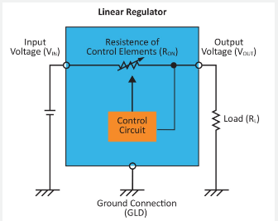

Figure : Linear voltage regulator with low dropout

### 3.5.2 Switching Regulators

### 

Due to their high efficiency, compact solution sizes, and versatility to step-down, step-up, or invert voltages, switching regulators are currently the most often used type of DC/DC power conversion. As implied by its name, switching regulators regulate the turning on and off, of a switch (transistor) to move energy from its input to its output. Some important additional elements required in a switch design include inductors and capacitors for energy storage and diodes for controlling the direction of currents. The magnetic field of the inductor stores and releases energy as the switch cycles on and off. Switching regulators can effectively transform power by controlling how much energy is kept or released by the inductor.

### 3.5.3 Voltage Regulator Selection

For the purposes of this project there may need to be multiple power supply regulators. The most common voltages being 12V, 5V, and 3.3V. Our supply voltage is from the battery with a nominal 36V DC. On the one hand linear regulators are very simple but have a low efficiency and switching regulators have higher efficiency but are more complex. We will choose a switching regulator for each of our main power voltages. These power circuits can be designed manually, but there are many free tools that can be used to design power circuits such as WEBENCH Power Designer by TI. Using these tools parameters can be used to choose high efficiency, low cost, small footprints, or a balance of all options. Once all components and their power requirements are determined we can use a tool to create our necessary circuit for the main control board.

## 3.6 Motors

### 3.6.1 AC Motor

An electric motor known as an AC motor, or alternating current motor, transforms electrical current into mechanical power through the use of a stator and a coil that are both powered by alternating current. AC motors can be single- or three-phase, with three-phase motors typically being used for converting large amounts of electricity. Small power conversions employ single phase AC motors. Due to their adaptability, efficiency, and quiet operation, AC motors are a power source for a wide range of applications. They are utilized on pumps, water heaters, gardening tools, off-road vehicles, and many other products, equipment, and appliances. As they can readily fit into a variety of applications, they are an engaging and interesting instrument.

|  |
| --- |
| **Types of AC Motors:** |
| Single Phase AC Motor |
| Polyphase AC Motor |
| Synchronous AC Motor |
| Reluctance AC Motor |
| Hysteresis AC Motor |
| Repulsion Motor |
| Asynchronous Motor |

Table : Types of AC Motors

The frequency and voltage of the circuit affect the speed and torque of an AC motor. With the help of variable frequency drives, you can control the speed and torque of your motor and maximize the efficiency of its operation. Variable frequency drives also known as VFD are seen in many industrial applications. Unfortunately, due to our own design constraints we could not go in the direction of an AC motor mainly due to its size and design.

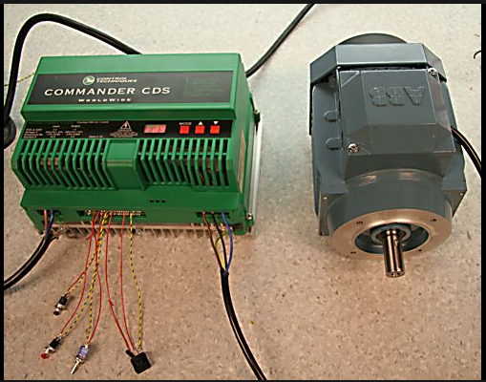

Figure : AC motor with VFD

### 3.6.2 DC Motors

A DC motor, also known as a direct current motor, is a type of electrical device that uses direct current to generate a magnetic field that converts electrical energy into mechanical energy. A magnetic field is produced in the stator of a DC motor when it is energized. Magnets on the rotor are drawn to and drawn away by the field, which rotates the rotor. The commutator, which is connected to brushes and the power source, supplies current to the motor's wire windings in order to keep the rotor turning continuously. The capacity of DC motors to precisely control their speed, which is essential for industrial gear, is one of the reasons they are favored over other types of motors. The ability of DC motors to instantly start, stop, and reverse is crucial for managing the functioning of production machinery.

Understanding the different types of DC motors is crucial to appreciating their advantages. Before buying and using, it is important to consider the advantageous qualities that each type of DC motor has to offer. The ease of installation and low maintenance requirements of DC motors over AC motors are two of their key benefits. The connections between the field winding and the armature distinguish different types of DC motors. The field winding can be connected in a series or parallel to the armature. The connection can occasionally be both parallel and in series. Whether a DC motor's rotor is operated by a brush, or a brushless motor is another way to distinguish them. Brushes in brush DC motors transfer electricity to the rotor. The rotor of a brushless DC motor is permanently magnetized. There is a different type of DC motor to suit any application's requirements because they are ubiquitous and used for a wide range of purposes. In regard to our project design, we have come to a decision in going forward with a DC motor due to the design and functionality of it.

|  |
| --- |
| **Types of DC Motors:** |
| Brushed DC Motor |
| Separately Excited DC Motor |
| Permanent Magnet DC Motor |
| Self-Excited DC Motor |
| Shunt |
| Series |
| Compound |
| BLDC Motor |
| Servo DC Motor |

Table : Types of DC Motors

### 3.6.2.1 Brushed DC Motor

Wound wire coils are used in DC motors to produce a magnetic field. These coils, which make up the "rotor" of a brushed motor, are free to rotate in order to drive a shaft. The coils are typically wound around an iron core, however there are brushed motors that are "coreless," meaning the winding is supported by itself. The magnetic field of the rotor must be rotating continually in order to attract and repel the fixed magnetic field of the stator, which in turn produces the torque that causes the rotor to spin. A sliding electrical switch is utilized to rotate the field.

The brushes and commutator experience mechanical wear over the course of the motor because there is some mechanical friction between them and since, as an electrical contact, they are typically unable to be lubricated. The motor will eventually stop working as a result of this wear. Large, brushed motors often include replaceable brushes made of carbon that are intended to retain good contact over time. Periodic maintenance is required for these motors. Even with replaceable brushes, the commutator eventually wears out to the point where a new motor is required.

The mass of the rotor, the brushes, and the commutator, as well as other factors, can all affect the rotational speed of brushed motors. Brush arcing can become more pronounced and the brush to commutator contact can become irregular at very high speeds. The rotor of the majority of brushed motors also contains a laminated iron core, giving them a high rotational inertia. This restricts how quickly the motor may accelerate and decelerate. Strong rare earth magnets on the rotor can be used to create brushless motors, which reduce rotational inertia. Naturally, that raises the price. This essentially is what makes the brush DC motor not viable for our design due to its short lifetime and low efficiency.

### 3.6.2.2 Brushless DC Motor

In a Brushless DC motor, the rotor's wire is instead powered by transistors in the electronic control circuitry, which creates an alternating current from a DC supply to reverse the current every half-cycle to achieve continuous rotation. Brushless DC motors often have higher torque-to-power ratios, are smoother and more efficient than brushed motors, and can operate at higher speeds with more precise control. They require less maintenance and have a longer useful life because there is no wear on a brush or commutator. The cost of the brushless motor, as well as the more complicated drive circuitry that is required, is one of its primary disadvantages.

Changing the control voltage can be done digitally using a microprocessor, or analogy with analog components. In order to activate the right phase at the appropriate time, the control circuitry needs to be aware of the motor's relative angular position. The rotational angle can be determined without sensors by inferring it from the back EMF produced by the magnetic field, or it can be determined with sensors by employing an optical encoder or Hall effect sensor. In either scenario, an all-in-one motor driver that combines the necessary features onto a single chip is frequently employed. This is what we are leading towards our design in the project.

|  |  |  |
| --- | --- | --- |
|  | **Brushless DC Motor** | **Brush DC Motor** |
| Efficiency | High | Low |
| Maintenance | Little | Frequent |
| Thermal Performance | High | Low |
| Output Power over Frame Size | High | Moderate |
| Speed/Torque Characteristic | Flat | Moderately flat |
| Dynamic Response | Fast | Slower |
| Speed Range | High | Low |
| Noise | Low | High |
| Lifespan | Long | Short |

Table : Brush vs Brushless DC Motor

### 3.6.2.2.1 Hub Motors

The hub motor, which is sleek and unobtrusive, is slowly becoming the go-to drive system for many light electric vehicles, including scooters, solar cars, and e bikes. External mounting brackets and drive chains are not required with a hub motor conversion to support a motor and transmission. Instead, everything is housed inside the wheel, which attaches to your bike just like any other wheel. Hub motors can be divided into two fundamental groups: direct drive and geared.

### 3.6.2.2.2 Geared Hub Motors

A geared hub motor has gearing inside of it to lower the high speed of a powerful and effective motor to the low speed of the wheel. A geared hub motor is typically wider and has a lower radius than a straight drive hub. They can have a variety of various internal configurations, but most typically they contain an outrunner motor that powers a planetary gear set attached to the rotor. The hub motor is straightforward to install and has the weight advantages of a transmission drive packaged into it thanks to the geared hub idea. They often weigh approximately 50% less than a direct drive machine of comparable power, and they frequently produce more torque. A conventional direct drive machine can only generate about 35 Newton-meters (N-m) of torque, however the German-made Heinzmann can generate up to 80 N-m.

A freewheel is within almost all the available geared hub motors. This eliminates the possibility of regenerative braking but implies that there is very little rolling friction to spin the wheel when the motor is off. Weighing these benefits of the geared hubs against their drawbacks is necessary. In general, geared hubs are more expensive, have several moving parts that are prone to wear, and make audible noise. Whereas geared hub motors with various speeds are theoretically possible, every device on the market right now only has a single speed. Some people fervently contend that e-bikes ought to feature a variety of transmission ratios so that the same 500-watt motor may both propel you slowly up a 15-degree hill and propel you quickly along a flat surface while always functioning in the vicinity of its peak efficiency zone. Yet if the market is any guide, the additional prices and difficulties from multi-speed drives surpass their advantages.

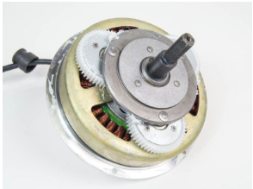

Figure : Geared hub motor

### 3.6.2.2.3 Direct Drive

The direct drive hub motor is as straightforward as they get. Think of taking an electric motor and holding the axle while allowing the motor's body to rotate. The only moving component is the wheel itself when you hook a bicycle rim to this rotating motor body. These machines are typically radial-flux Brushless DC (BLDC) units with a grid of permanent magnets on the hub's interior surface. Alternating currents passing through the stator windings, which are connected to the axle, cause the hub to rotate. In a DC hub motor, the windings are spinning on the interior of the hub while the magnets are on the axle.

Through a commutator plate, a carbon brush delivers energy to the rotating windings. The direct drive system's one drawback is that, considering their power output, they are typically big and heavy. The wheel speed is only about 200 rpm, which is the cause of this. Since the speed between the magnets and the winding is directly related to the power density available from an electric machine, a large motor is required to produce enough power and torque. A considerably smaller motor can produce the same amount of power in a geared transmission since the motor is frequently rotating at speeds over 3000 rpm.

Direct drive hub motors all have the feature of always being mechanically engaged. Something has both good and bad aspects. It is advantageous because it enables regenerative braking. Whether they are designed to do so or not, all direct drive hub motors can be engineered to do regeneration. In contrast to the majority of Chinese kits like Crystalyte, Golden Island, and Wilderness Energy, the BionX and TidalForce both contain sophisticated controllers that enable varying amounts of braking energy to be stored back in the battery. Constantly engaged is undesirable since it implies that even when the motor is not being used, you are constantly overcoming its rolling resistance. This additional drag torque can range from being invisible to making you feel like you're always riding with a flat, depending on the symmetry and quality of the motor.

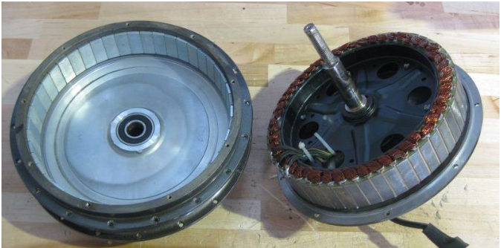

Figure : Direct Drive Motor

### 3.6.2.2.4 Direct Drive vs. Geared Hub Motors

In the table provided below is a general comparison of the Direct Drive and Geared Hub Motors. With the data that was collected and researched we came to terms with the categories in which we deemed to be important for our design specifications.

|  |  |  |
| --- | --- | --- |
|  | **Geared Hub** | **Direct Drive** |
| Energy Efficiency | High Efficiency | Lower Efficiency |
| Torque | Higher in torque | Low in torque |
| Weight | Lighter in weight | Heavy in weight |
| Performance | Low performance | Higher performance |
| Price | Cheaper | Higher in price |

Table : Comparison of Motor types

### 3.6.2.2.5 Hall Sensors

### 

 A BLDC motor's commutation is electronically controlled in contrast to a brushed DC motor. The stator windings should be activated sequentially to turn the BLDC motor. Understanding which winding will be powered after the energizing sequence depends on knowing the position of the rotor. Hall effect sensors built within the stator are used to determine the position of the rotor.  On the non-driving end of the motor, the stator of most BLDC motors has three hall sensors included into it. The hall sensors provide a high or low signal whenever the magnetic poles of the rotor get close to them, indicating whether the north or south pole is doing so. The precise commutation order can be calculated using the combination of these three hall sensor signals.

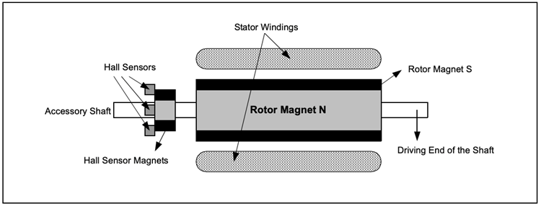

Figure : Tranverse Section of a BLDC Motor

A BLDC motor with an alternate north and south permanent magnet rotor is shown in transverse in the following figure above. The stationary portion of the motor contains Hall sensors. Because any misalignment of the Hall sensors with respect to the rotor magnets will result in a mistake in determining the rotor position, embedding the Hall sensors into the stator is a difficult task. Certain motors may include the Hall sensor magnets on the rotor in addition to the primary rotor magnets, making it easier to place the hall sensors onto the stator. They are a miniature duplicate of the rotor.

As a result, the hall sensor magnets have the same impact as the primary magnets whenever the rotor turns. Typically, the hall sensors are fastened to the enclosure cap on the non-driving end by being installed on a PC board. This gives customers the ability to align the entire hall sensor assembly with the rotor magnets for the greatest performance. There are two different forms of output depending on where the hall sensors are physically located. The phase shift between the Hall sensors can be 60 degrees or 120 degrees. Based on this, the manufacturer of the motor specifies the commutation sequence that must be used while operating the motor. Especially these being a major component in regards to our specifications within our design.

### 3.6.3 Motor Selection

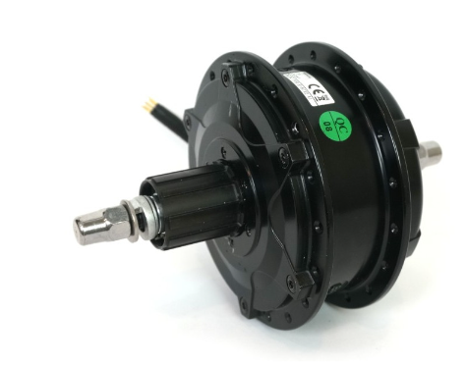

Figure : Bafang G310 Motor Schematic

|  |  |
| --- | --- |
| **Specifications** | **G310 Motor** |
| Actual weight (kg) | 2.55 |
| Power Range (Watts) | 250 - 500 |
| Motor KV (RPM/V) | 8.5 |
| Phase Resistance (Ohm) | 0.124 |
| Disk Brake Compatible | Yes |
| Connectors | Z910 |
| Thermistor style | 10K NTC, B – 3450 with 10K pullup Multiplexed with Speedo |
| Axle Length | 138 |
| Axle Threads | 3/8” x 26 tpi |
| Spoke holes | 36 Hole |
| Motor type | Geared |
| Flange Spoke Diameter (mm) | 123 |
| Magnetic Pole Pairs (Phaserunner) | 88 |
| Hysteresis Losses (N-m) | 0.666 |
| Eddie Losses (N-m / rad/sec) | 0.015 |
| Motor Inductance (H) | 0.00021 |

Table : Motor Design Specifications

With a lot of the research that was conducted in terms of the motor we came to the decision of choosing a geared rear hub motor. The one in which we are looking at is the *Bafang G310 Standard Wind (8.5 rpm/V) Geared Rear Hub Motor*. The *Bafang G310* motor is a 2.5-kilogram rear hub that is compatible with small disks and has a nominal 250–350-watt power rating. It works well for covert systems that don't need much assistance for steep slopes or heavy loads. In order to use a CA-DP device and avoid the need for an external speedo pickup, this motor has an integrated 6-pole speedometer sensor. It has spiral gears on a second stage planetary gear's first reduction and is remarkably quiet for a geared motor. uses a side cable exit and a cassette freehub mechanism rather than a screw-on freewheel. This hub has a typical RPM/V winding that is appropriate for 26" and 700c wheels. The motors price point before tax is at about $240 USD.

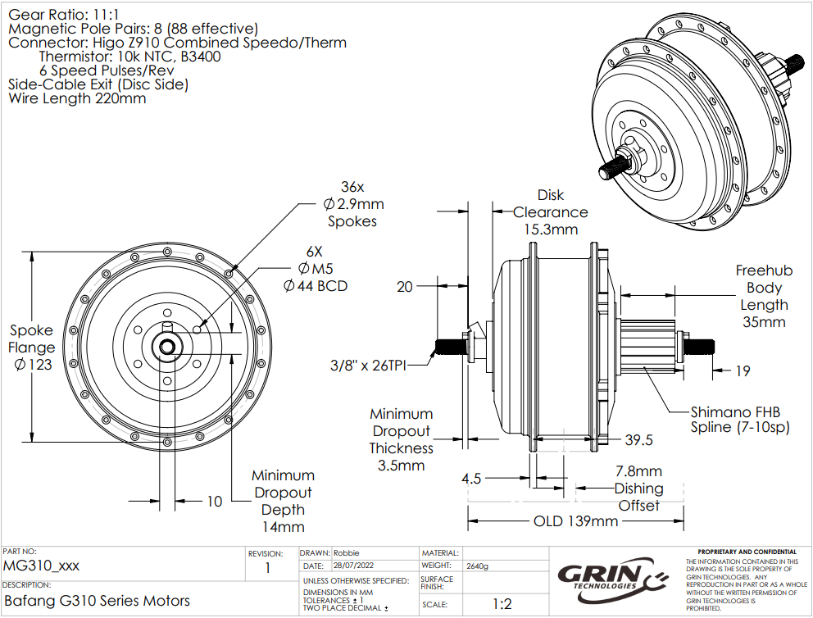

Figure : Bafang G310 Motor Schematic

## 3.7 Throttle Controls

The following section is an evaluation of the different types of throttle controls that an operator can interact with to propel an e-bike. There are a few different kinds of throttles; each has their pros and cons, and they should be weighed against each other to determine which is best for the project.

### 3.7.1 - What is an E-Bike Throttle?

According to the Oxford dictionary, the technical definition of a throttle is a device that controls the flow of fuel/power to an engine. Typically, the operator of a vehicle is the one that has access to the throttle. Although an e-bike does not have nor requires fuel to operate, it does require power and a device to control how much power is provided. This device is what the operator uses to propel the e-bike and control the power flow to the motor. This specification is the reason why this device is classified as a throttle.

### 3.7.2 - Popular Throttle Types

If one has ever ridden a motorcycle or an electric scooter or anything of the like, they’ll know that the throttle on these vehicles is located at the handlebars. An e-bike's throttle is typically located at the handlebars as well for ease of access for the operator. Since it is typically located at the handlebars, the weight/size of this device is something to consider. If this device is too heavy, it can negatively impact the operator’s intent on directional control. If this device is too big, then it will negatively impact the operator’s comfort when operating the e-bike. To minimize the weight/area this device takes up, some compact designs for throttles have become popular. Of these compact designs, there are two to make note of:

1. Twist Throttle

The twist throttle is a throttle device located in the handle of the e-bike itself. This is identical to the throttle a motorcycle uses. The handle can be twisted; the more it’s twisted, the more power is output, thus more acceleration is experienced. There are two types of twist throttles:

* 1. Half-twist throttle

Only the inner half of the handle can twist to control speed

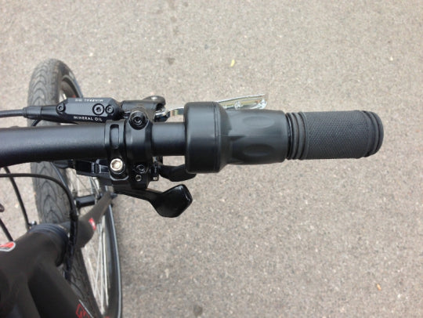

Figure : Picture of a half-twist throttle on an e-bike (copyright pending)

* 1. Full-twist throttle

The entire handle can twist

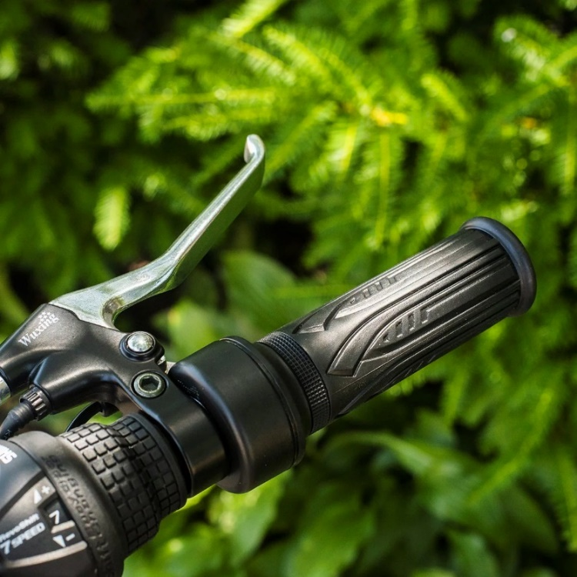

Figure : Picture of a full-twist throttle on an e-bike (copyright pending)

1. Thumb Throttle

The thumb throttle is located at the edge of either the left or right handle, fashioned in such a way that the thumb can comfortably rest on it. To engage the throttle, the operator presses their thumb down on the throttle’s tab.

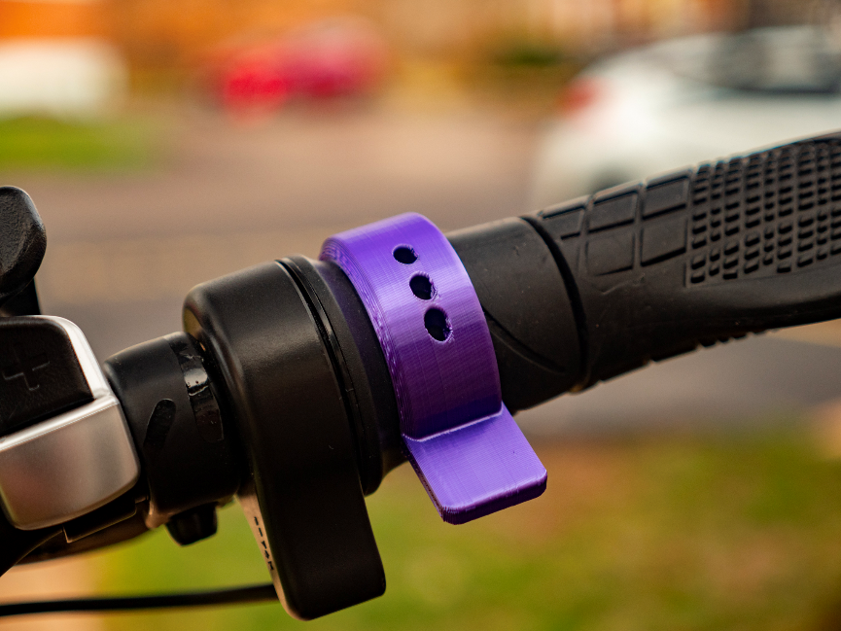

Figure : Picture of a thumb throttle on an e-bike (copyright pending)

### 3.7.3 - Consideration for Project

Both throttle designs are popular in the e-bike community. Although, there appears to be a debate surrounding which design can be considered “better” than the other. This, one can assume, comes down to personal preference. When it comes down to which will be used in this project, that will be the result of the same debate: which is the design the group prefers. There are numerous things to consider when making such a decision, as either throttle choice has its pros and cons. Below is a quick list of these pros and cons for each of the throttle types.

Twist throttle pros and cons:

* Pros
  + Allows for the operator’s entire hand to maintain contact with the handle
  + Can be more comfortable over long distances over the thumb throttle, as long as frequent speed changed are not required
* Cons
  + If frequent speed changes are required, then constant adjustments must be made; this can introduce wrist fatigue
  + May give uneven handle feeling, as the throttle handle may be much bigger than the other handle
  + May be difficult to implement, as an entire handle must be replaced
* Half twist vs full twist
  + Half twist
    - Pros
      * Smaller than full twist, more compact
      * Less accidental engagements
    - Cons
      * May be the most difficult to attach
      * May not be as comfortable as full twist
  + Full twist
    - Pros
      * Larger than full twist; better control
      * May be easier to attach to e-bike
      * May be more comfortable for hand
    - Cons
      * Prone to accidental engagements when running to wall/object

Thumb throttle pros and cons:

* Pros
  + Will not introduce wrist fatigue with constant speed adjustments
  + Easier to implement; a thumb throttle attaches to the handlebar as is
  + Prevents uneven handle feeling as both handles will be the same size
* Cons
  + May be less comfortable over long distances, as the thumb is doing all the work to maintain speed
  + Operating e-bike over difficult, bumpy terrain can impact operator’s reliability to maintain speeds
    - If the bike goes up and down, so does the thumb

If the group decides they want to focus on giving the e-bike a sleek and minimal look/feel or are more comfortable with twisting their wrist, then the twist throttle should be considered.

If the group decides they prefer a static hand grip and are uncomfortable with twisting their hand, then the thumb throttle should be considered.

|  |  |  |  |
| --- | --- | --- | --- |
| **Throttle Type** | **Comfort** | **Implementation Ease** | **Grip Rigidity** |
| Thumb | Low | High | Low |
| Half-Twist | High | Lower than Thumb | High |
| Full-Twist | High | Lower than Thumb | Higher than half-twist |

Table : Types of Throttle

## 3.7.4 Throttle Selection

For the throttle on the e-bike, the group has decided to go with a twist throttle; the full-twist, specifically. For this selection, the *Keenso Full-Twist* throttle will be used.

## 3.8 Torque arm

Torque arms are used in hub motors in order to prevent axle rotation. Essentially with the torque being generated one way there is an equal amount of it in the opposite direction. Most electric bike hub motors have flats carved into the axle that fit into the dropout slot and provide some rotational stability. Nonetheless, in high power systems that generate a lot of torque or in designs with weak dropouts, the forces present may be greater than the material strength and push the dropout open. The axle will spin freely in that scenario, possibly causing the wheel to fly off the bike and wrapping and severing the motor cables. When looking for a viable option for the torque arm there are some factors in which to take in account. The material in which you are looking for is stainless steel for how strong and durable it is. Next being the thickness of the torque arm needs to be looked at when selecting it. In most cases thicker is better so that it is able to have more of an effect in the design. An estimated measurement that is recommended is about a quarter inch or 0.635 cm. Lastly is the length in which the axle is from the point where the torque arm is mounted to the frame. Greater the distance equates the amount of force that is being resisted on the torque arm.

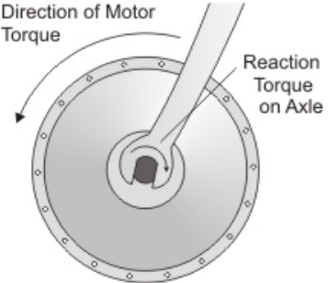

Figure : Torque Arm (Copyright pending)

## 3.9 Brakes

Brakes are used as a way to slow down objects that are in motion that need to stop. There are many different types of brakes used on bicycles, however, only two are widely used which are rim brakes and disc brakes. There are three more brakes used by bicycles, however, they are not as common as the previous two so the information given for those brakes will not be as in depth compared to the first two. We may need to replace ours with due to the fact that the brakes currently on our bicycle was not designed to stop someone using a motor to propel themselves.

The company REI and the website bikeradar.com state that the most common type of brakes on bicycles today are rim brakes or disc brakes. They each have different opinions on which brakes are used on bicycles other than the two stated above. REI states that coaster and drum brakes are also used on bicycles while bikeradar states that V-brakes are used. The safety standards for all of the brake types will be found in 4.0 related standards and design constraints.

### 3.9.1 Rim Brakes

These brakes use the rim of the wheel in order to apply a force to slow down and to stop. They are simple using only a wire on the bicycle we currently plan to use for the project. Currently rim brakes can cost anywhere from $10 up to $544. This wide range of price is most likely because of materials used or if a company has a sort of “elite” status like AppleTM has.

These brakes have upsides and downsides as with any item with an upside being a lower cost compared to other brakes. The downsides consist of poor performance when it rains, which is common occurrence in Florida depending on the season, however, this can be overcome if a proper pad is used. There are also issues of mud and snow with snow being a non-factor in Florida. There are different types of rim brakes that can be used and the main difference between them is the way the force is applied. For example, a rod-actuated brake uses rods and pivots to apply force on the rim when the brake is squeezed to apply pressure. The one on the bike that is being planned to be used are called side-pull caliper brakes but those also have a subdivision with one being a single-pivot side-pull caliper brakes and the other being a dual-pivot side-pull caliper brakes. Below is the type of brake currently on the bike.

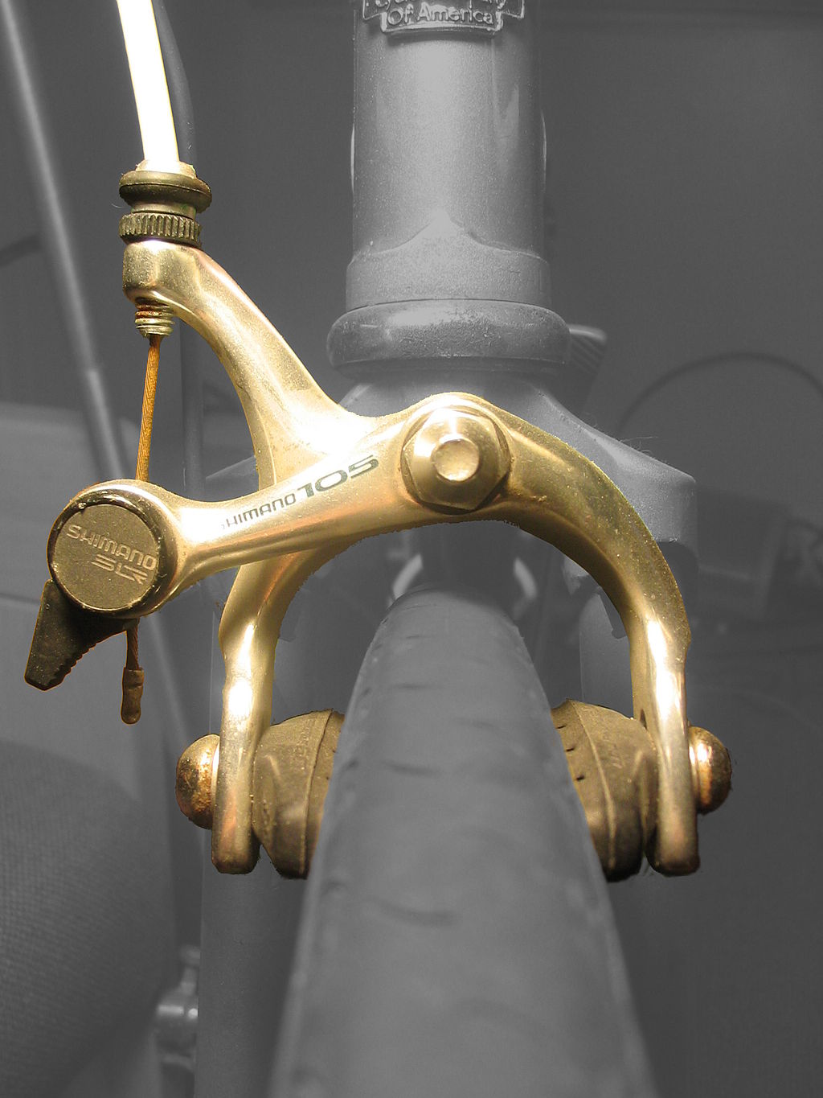



Figure : Single pivot-side-pull caliper brake

These are brakes that are generally used on narrow tires because with a wider tire the force applied decreases.

On figure 23 there are labels that show the major parts of the caliper brake. At A and B is what the person moves when pulling on the brake. The two parts move closer together causing C to pivot causing D and E to get closer to the rim until one is touching then as more force is applied the other touches. When not being pulled the spring inside C makes the pads D and E stay away from the rim of the tire.

### 3.9.2 Disc Brakes

These brakes are attached at the wheel hub of the tire that rotates along with the tire. While rotating a force can be applied to the disc to slow or stop the bicycle. A disadvantage is heat dissipation because it is possible to have a small surface area if you need a small disc brake because of weight reasons compared to rim brakes. An example of a dick brake is below.

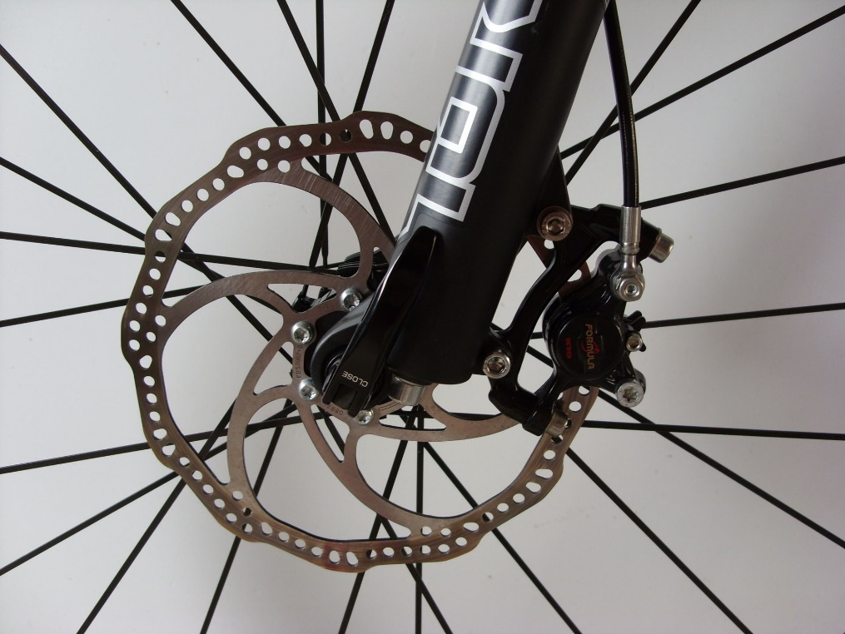



Figure : Hydraulic disc brake

The reason for the holes in the disc is to help reduce weight and with heat dissipation. While rims are inherently part of the design on a bicycle (the wheels) a disc brake is an addition to the bicycle that must be added to after the fact. This would not be best when we are trying to make the e-bike have a higher speed and have a longer lasting battery.

On figure 24 there are labels that will be used to explain more about the disc brake. A is a line where force is used to push on B the caliper. A could be hydraulic or cable actuated. C is the rotor that the caliper applies force to in order to slow down or stop the bicycle.

### 3.9.3 Coaster Brakes

A coaster brake is engaged when the pedal is rotated in the opposite direction, an amount that can be changed depending on the distance between the clutch and the driver side expander. During normal operation (moving forward) the clutch grabs onto the casing so the wheel and casing are moving in sync. When back pedaling the clutch goes along a thread to push against the driver side expander. This expander goes inward pushing internal plates up against the casing which causes friction against the container slowing you or stopping you.

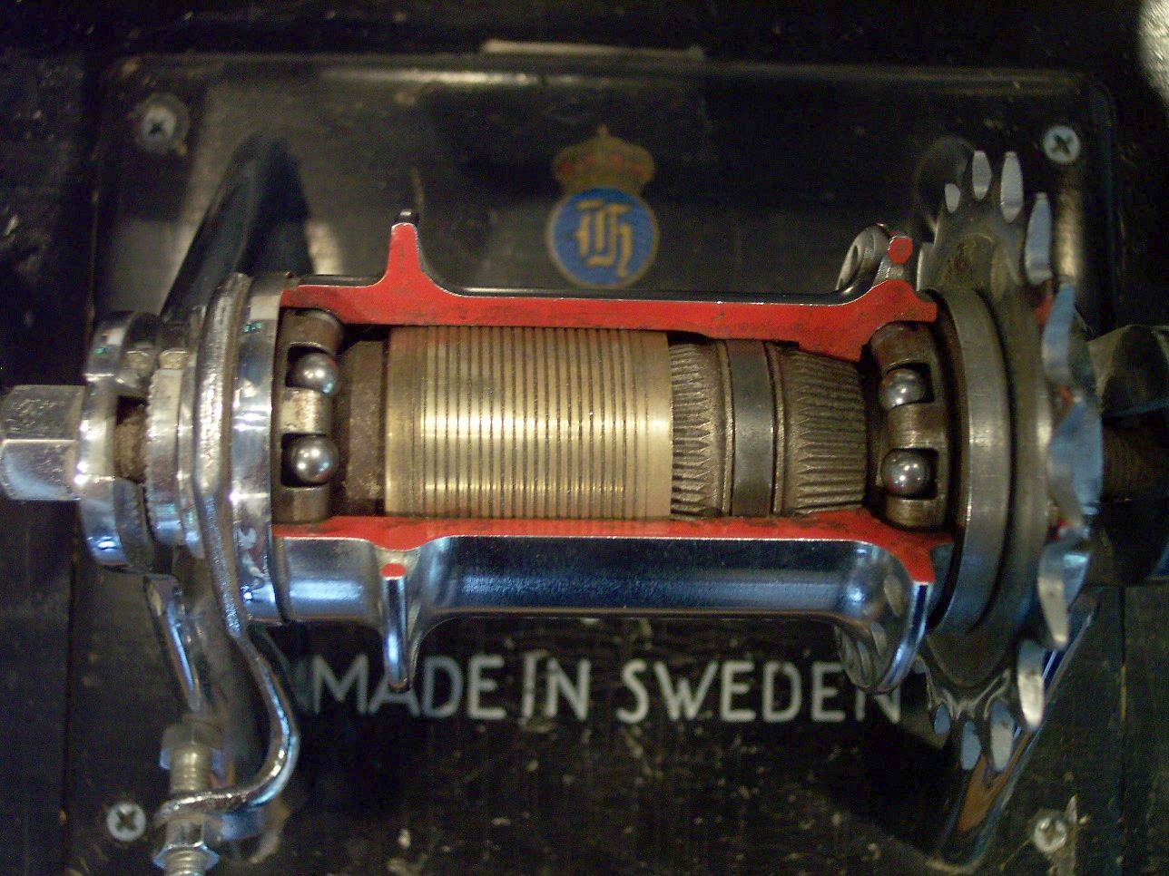



Figure : Inside a coaster brake

In the picture above the red square is the clutch which has teeth that grabs onto the white box (driver side expander) which then pushes the orange box (brake pads). The brake pads have a slope on the underside of them so when the clutch is not engaged, they rest on top of the expander and apply no force to the container. To disengage the brakes going forward with the pedals release the brake pads.

### 3.9.4 Drum Brakes

These can also commonly be seen on cars and use a wheel cylinder to push the brake pads (also called shoes) against the drum to apply the friction required to slow or stop. This is similar to the coaster brake in that they both push metal on metal to stop or slow down. The drum brakes, however, use springs in order to disengage the brake pads from the drum. In a vehicle hydraulics are used to engage the brakes but, in a bicycle, cables are used 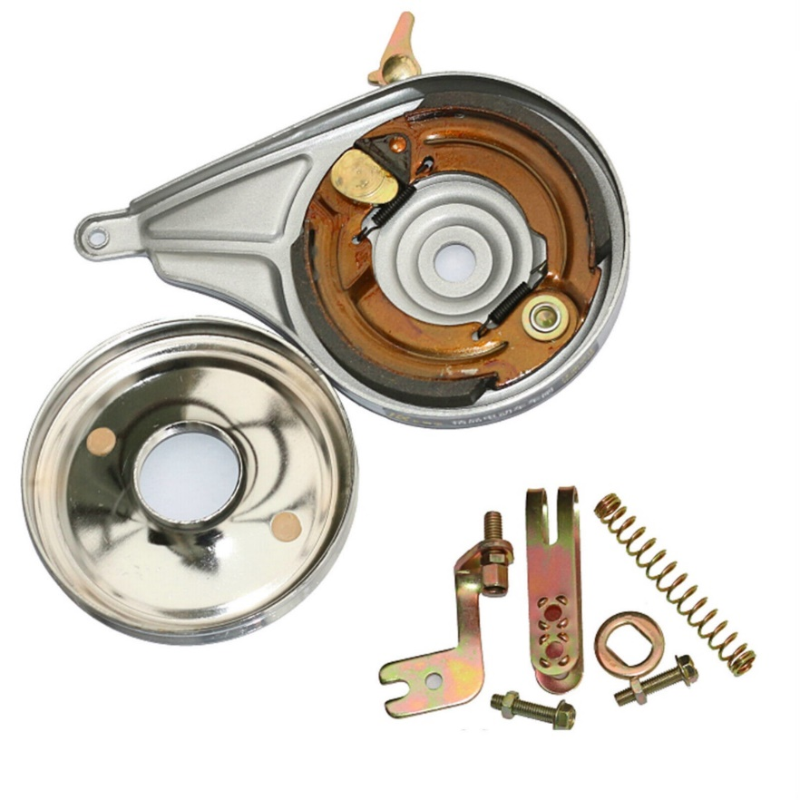instead.



Figure 26: Internal of a drum brake

Figure : Internal of a drum brake

In the picture above the black are the brake pads while the red is the wheel cylinder. When a force is applied the brake pads are pushed into the sides of the drum to apply friction.

## 3.9.1 Brake selection

There are a few different types of brakes we could use, however, we will need to determine what would be the best option for the e-bike we will use based off the requirements we have. The two most common are the rim brakes and the disc brakes. Each has their own positives and negatives that will need to be taken into account when deciding which one to utilize.

The speed of the e-bike will be going fairly fast with a max of 19.5 miles per hour so as not to go beyond the class two e-bike. We can look at automobiles for some inspiration for the type of brakes we should use. Automobiles use disc brakes because of the stronger stopping power over that of other types in the front, however, recent information states that disc brakes are now used on all wheels. This is an option for an e-bike that we could consider because of the added momentum and weight that is added because of all the parts added to the e-bike.

|  |  |  |
| --- | --- | --- |
|  | **Rim brake** | **Disc brake** |
| Market availability | High | High |
| Cost | High | Medium |
| Heat dissipation | Low to high  Depends on size of disc | High |
| Weight | High | Low |
| Reliability | High | Medium |
| Ease of replacement | Low | High |

Table : Comparing Types of Brakes

From the table we can see these differences between the two most common types of brakes along with their positives and negatives. We will need to decide if we want the disc brakes but because of the nature of the project rim and the use case for the bicycle, rim brakes should be fine. They should also allow easier replacement and are cheaper if something does go wrong or brakes while testing or fixing the e-bike.

The rim brake type we would use is a dual-pivot side-pull rim brake. The reason for this is the better braking compared to other rim brake types. Below is an example of that type of rim brake.

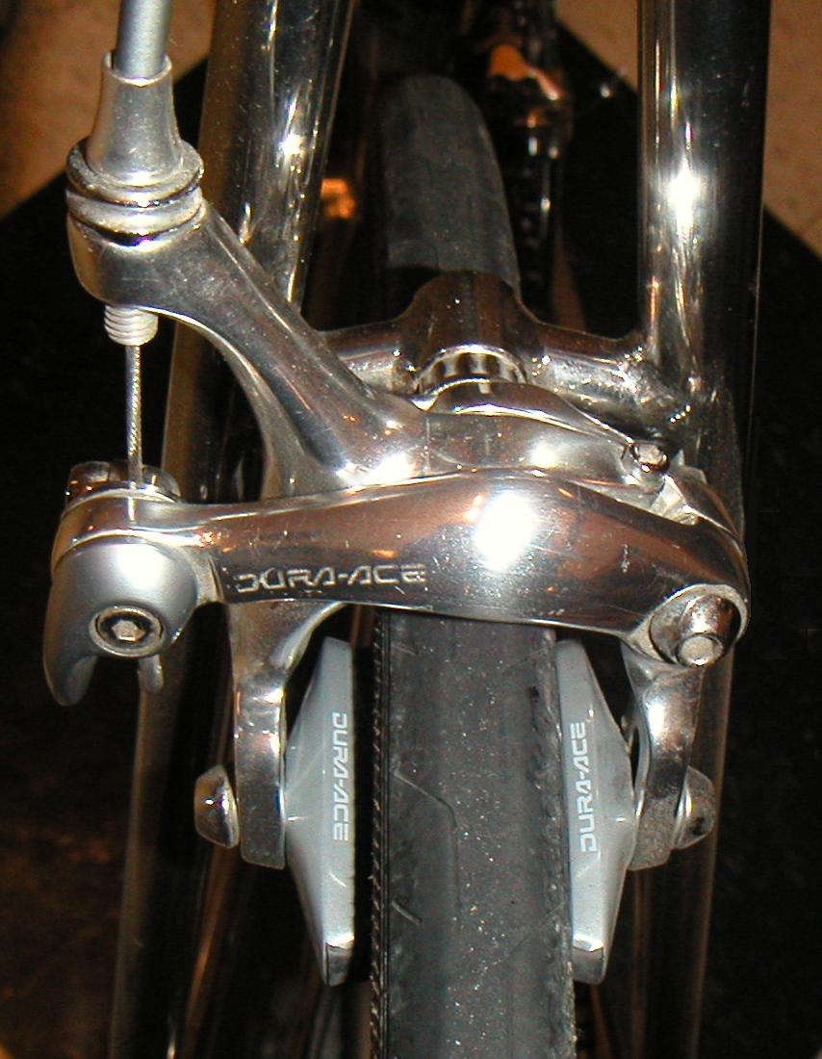

Figure : Dual pivot side-pull caliper brake

The current choice is *SUNLIGHT Dual Pivot Brake Caliper, 39-49mm Reach*. This is because the cost is low and we will also need to purchase a cable set so it is not too much extra work and would allow us to have a better understanding of how these rim brakes work.

## 3.10 - App

The group has decided upon building a multi-function smartphone companion application for the e-bike. This application will connect to the e-bike via Bluetooth and send & receive information to and from the e-bike. This will be made possible by the aforementioned Bluetooth module in section 3.4. The application will mainly behave as a heads-up-display (HUD) for the operator of the e-bike. The e-bike will feature a phone clamp on the handlebars and, along with the application receiving information, can be used as a visual display for certain statistics associated with the e-bike’s function: current speed, remaining battery charge, and current battery usage, amongst other things.

There are different options for developing an application. The group can either opt to:

* Develop a web application that a smartphone can access via a web browser, or
* Develop an executable application specifically for the smartphone

Both options have their advantages, and both must be considered to find the best possible option for the group.

3.10.1 – Browser Web Application

With an application comes a technology stack that is used to build the application. A technology stack is a collection of technologies used to build an application. A stack is typically identified by either an abbreviation or a short phrase. For example: a LAMP stack. LAMP is an abbreviation used to identify the technologies: Linux, Apache, MySQL, and PHP. The abbreviation does not always identify the same scope for each letter.

When it comes to experience, however, there are two technology stacks the CpE group members are familiar with: LAMP and MERN stacks. When it comes to a certain stack that the group has mentioned may work the best for the project

When considering which one will function the way the group requires, any of the choices we come across are feasible. We are given freedom to use whatever technology we desire, though this technology must be something that can we are capable of using properly to achieve our goals. That being said, the main factor to consider when deciding which technology stack to use would be whatever the group is most comfortable with using.

3.10.1.1 – LAMP Stack

The LAMP stack, as previously mentioned, consists of Linux, Apache, MySQL, and PHP. Linux is used as the operating system (OS), Apache is web server software and is used to host the application, MySQL is used for databasing and storing information, and PHP is used for API calls between the UI and the database, sending and receiving information.

According to Amazon, the following five concepts are why a LAMP stack is an important contender for consideration when building an application:

* Cost
  + Cost is an extremely important factor when considering technology to use. Fortunately, all of the components of a LAMP stack are free. A developer is capable of downloading all the technologies and using them without spending a dime.
* Efficiency
  + LAMP is a tried-and-true tech stack that has been used numerous times. This can prove to be efficient, as the technologies are familiar to most developers, saving time to learn and set up.
* Maintenance
  + The maintenance of the technology involved with LAMP very good, as software experts from around the world contribute towards its development and maintenance.
    - There will still be maintenance on the developer’s side for app-specific issues, but issues with the stack are well-maintained.
* Support
  + The number of developers around the world using LAMP is, to exaggerate, astronomical. The amount of documentation provided by its IT community can prove to be extremely useful, as experience is the best form of troubleshooting.
* Flexibility
  + The LAMP stack is flexible as certain technologies within the stack can be replaces by others. For example: Linux can be replaced by either Windows or MacOS to result in a WAMP or MAMP stack, respectively.

A LAMP stack would be a great option for app development, after considering the above reasons. However, to consider everything about it, not everyone in the group is familiar with Linux, since although it’s a popular operating system, it is not as broadly used as Windows and MacOS are.

LAMP stacks are also better used for backend applications, ones that are hidden from end users. While DOM technologies can be incorporated into a LAMP stack to produce user interfaces (HTML, CSS), they are not explicitly included.

3.10.1.2 – MERN Stack

A MERN stack, similarly to a LAMP stack, is an abbreviation for the technologies used within its development. A MERN stack consists of the following technologies: MongoDB, Express.js, React.js, and Node.js. MongoDB is the database technology, Express.js a JavaScript web server framework, React.js is a front-end JavaScript library, and Node.js is a runtime environment.

Using similar factors to Amazon’s evaluation of the LAMP stack:

* Cost
  + A MERN stack is not completely free, as MongoDB alone has a bit of cost to use, based on how much storage one requires. The other technologies are free frameworks/libraries open to use for everyone.
* Efficiency
  + The efficiency of a MERN stack is very high, as the web server, frontend, and runtime environment are all written in JavaScript.
* Maintenance
  + Maintaining a MERN stack application can prove to be quite simple since everything is written in one language. The learning curve begins with using MongoDB, as it is a document-based, no-SQL database. If one is primarily used to SQL databasing, this may prove difficult.
* Support
  + MongoDB is a company with a good support platform. They have entire websites dedicated to assistance for their customers. The JavaScript technologies in the stack would also prove to have good support as JavaScript is a very popular scripting language; the global IT community is very present in providing support for certain issues.
* Flexibility
  + The MERN stack is very flexible. Instead of using React.js for the frontend framework, once can opt to use Angular.js or even Vue.js, resulting in a MEAN stack or a MEVN stack.

3.10.2 – Smartphone Application

There are many things to consider when developing an application directly for a smartphone, with the most important factor being: which platform should the application be developed for: iOS, Android, or something else? For some, this is a simple answer: whichever they prefer the most. However, in this group’s case, both iOS and Android platforms are an option as the group holds access to both.

3.10.2.1 - Platform

The platform that the application is developed for is incredibly important for development. Popular platforms that are available for development are iOS and Android; these two options not only dominate the smartphone market, but also are the only two platforms that the group holds access to. Either one of these would be a great option for development, since these operating systems are developed by incredibly large corporations that provide fantastic tools to assist with development.

* iOS
  + iOS applications are developed with Apple’s own programming language: Swift. Applications also rely on Apple’s XCode tool for development, which, apparently, is easy to work with. The unfortunate thing here is that XCode does not run natively on Windows computers, so either a Mac would be required for development, or a virtual machine running macOS.
* Android
  + Androids depend on Android Studio for development, which was introduced by Google in 2013 and has continued to be a frontrunner for Android app development for almost that entire decade. Android studio uses the Kotlin programming language to develop applications. An advantage of Android Studio is that it, while utilizing a plugin, can develop cross-platform applications for both iOS and Android devices.

3.10.2.2 – Flutter and a BaaS

One thing that the previously mentioned technology stacks have in common is their incredible ability to develop web applications. One thing they specifically lack, however, is the ability to port the web applications into mobile smartphone applications. Not only is this portability an issue, but also being able to port the web application to multiple different platforms.

This is one of the main advantages of Flutter. It is a UI framework developed by Google that uses its own Dart programming language, which is also developed by Google. Flutter is capable of compiling developed applications for multiple different instruction architectures; in the scope of this project, using Flutter would mean developing an application for iOS and Android devices at the same time. This would prove extremely useful since the group does not all share the same operating system on their smartphones, so using a technology that compiles into both operating systems enables the application to be more inclusive with testing.

Alongside Flutter would be a Backend-as-a-Service (BaaS). A BaaS is a simple way for developers to automate certain backend development processes and provide a cloud infrastructure management that is simple to work with. There are many choices for a BaaS to pair with Flutter. There are a few that are popularly used and are worth considering:

* Back4App
* Parse
* Firebase
* Backendless
* AWS Amplify

The above options provide similar functions to each other, while all having similar price points. These options are not free but are worth seriously considering, as streamlining app development for a negligible price tag seems more than worth it.

Approaching Flutter and BaaS similarly to the other tech stacks:

* Cost
  + Will cost more than the other two listed options.
* Efficiency
  + May be less efficient in learning to use the technology, since both Flutter and Baas are new concepts to the group. However, once enough learning has been done to develop, development efficiency would be unparalleled, considering the automation capabilities of a BaaS as well Flutter’s compilation into multiple architectures.
* Maintenance
  + Depending on which BaaS would be selected for the pairing with Flutter, there would be incredible maintenance for these technologies. For example: if Firebase were selected. Both Flutter and Firebase are developed and maintained by Google. AWS Amplify is developed and maintained by Amazon.
* Support
  + Google invested a lot of its resources into Flutter; it can be assumed having a great support team is part of this investment. The same applies to the BaaS options as well, regardless of which one it is.
* Flexibility
  + Contrary to the other great evaluations, the flexibility of Flutter is very low, if there’s any at all. Dart is a programming language unique to Flutter, so applications developed on Flutter would have to stay on Flutter.

Using a ranking system of 1, 2, and 3 to rank the solutions on a comparison table (1 being the most optimal):

|  |  |  |  |  |  |
| --- | --- | --- | --- | --- | --- |
| **Technology** | **Cost** | **Efficiency** | **Maintenance** | **Support** | **Flexibility** |
| LAMP | 1 | 3 | 2 | 2 | 1 |
| MERN | 2 | 2 | 3 | 3 | 2 |
| Flutter, BaaS | 3 | 1 | 1 | 1 | 3 |

Table : Comparison Table of Browser Web Apps

## 3.10.1 App Design

When considering many different factors including, but not limited to testing inclusion, learnability, and progress efficiency, the group has decided to use *Flutter* as the UI framework for the smartphone companion app, as well at utilizing a BaaS; specifically, we are choosing *Firebase*. This is to keep the technologies developer-consistent since both Flutter and Firebase are developed and maintained by Google. It can be expected that the documentation and support for both are of good quality/availability.

Although this may lead to being the most expensive solution, it will, no doubt, save the team a lot of time with development.

3.11 – Lights

On most vehicles found today exist lights to some degree. Whether they are lights on the front of the vehicle to illuminate the forward surroundings of the vehicle operator for clarity, or whether they are indication lights found elsewhere on the vehicle to indicate to others the direction the vehicle is going.

The group has decided that that placing not only front-facing illuminating lights but also indication lights on the e-bike is ideal. Not only is this ideal for operating a vehicle, it is also required by Florida state law, which states that bicycles must exhibit a white light on the front and a red light & reflector on the back. While operating an e-bike can be considered fun and entertaining, it must be safe not only to the operator, but to the operator’s surroundings as well. Lights to illuminate the road ahead of the operator and to indicate deceleration (brake lights) are going to be implemented. Lights to indicate change of direction/turning (turn signals) can be implemented if time allows.

There are two common technologies used to produce light: incandescent light bulbs or light emitting diodes (LEDs).

### 3.11.1 Incandescent Bulbs

Incandescent bulbs are the bulbs that are found most in vehicles as well as households. These bulbs consist of a glass bulb with a filament inside hooked up to a circuit that applies a current to the filament. The filament then heats up to a significant temperature (around 3500° – 4500°F) and radiation is emitted from the filament. This radiation is in the form of visible light. The term “incandescence” means to obtain light from heat.

Because of the functionality of incandescent bulbs, their total lifespan can be relatively short compared to other lighting technologies (around 1,200 hours). Not only is their lifespan very short, but they are also notoriously power-inefficient. This group’s e-bike is dependent on a single battery to operate everything electricity-based, so power efficiency is and incredibly important factor to consider.

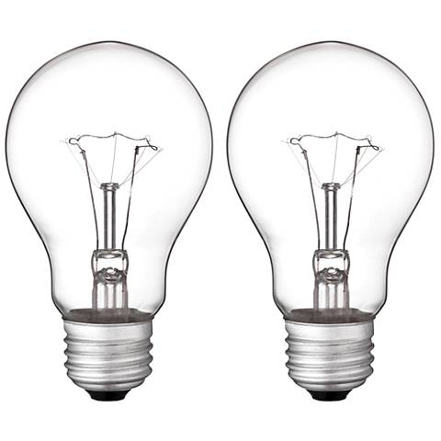

Figure : A pair of incandescent bulbs (Copyright pending)

### 3.11.2 Light Emitting Diodes (LEDs)

Light emitting diodes (LEDs) are indeed a common lighting solution, however a smidge more expensive. LEDs consist of a semiconductor diode that produces light when a current is passed through it. Heat is generated in this scenario as well, but most LEDs implement heat sinks to pull heat away from the diode itself. LEDs capability to manage its thermal output is a significant factor in how long their lifespan is, which, compared to incandescent bulbs, is roughly 20-150 times longer (based on an average lifespan of 25,000 to 200,000 hours).

Not only do LEDs provide a longer lifespan, but they are also more power efficient. As previously mentioned, power efficiency is incredibly important to this project, as everything is being powered by a single battery. Since LEDs not only last longer but also are more efficient than incandescent bulbs, they would be wiser to select these when implementing lighting systems onto the e-bike. Even though they do cost more than incandescent bulbs, the money will be well spent.

|  |  |  |  |
| --- | --- | --- | --- |
| **Lighting Solution** | **Cost** | **Efficiency** | **Lifespan** |
| Incandescent Bulbs | Low | Low | Low |
| LEDs | Relatively higher | Vastly higher | Vastly higher |

Table : Lightning Comparison

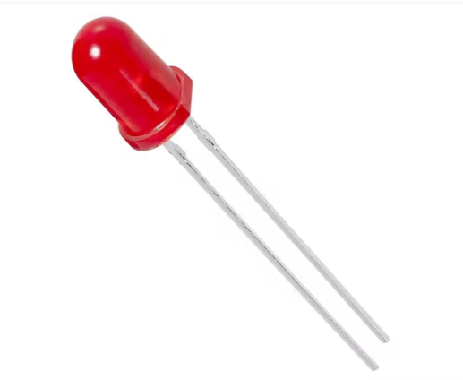

Figure : A single, standalone LED (Copyright pending)

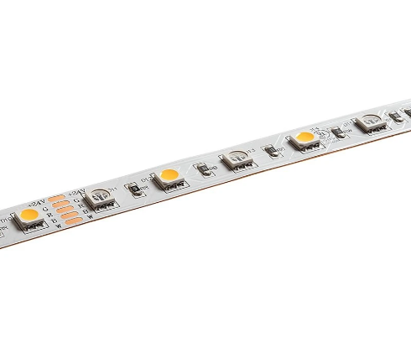

Figure : An LED strip (Copyright pending)

## 3.10 Lights Selection

Considering the options available for lighting, LEDs seem to be the most reasonable. Although they do cost a little more than incandescent bulbs, not only are they more reliable and dependent, but they are also much more power efficient. So the group has decided to go with LEDs for lighting on the e-bike.

There are many options of LEDs to choose from, but the group has opted to go with a strip of LEDs; specifically the *Adafruit RGB LED Weatherproof Flexi-strip 1m* strip of LEDs. This gives us the flexibility to cut and reuse sections of LEDs, with plenty of leeway in case any of the other pieces get damaged/become broken.

# 4.0 Related Standards and Design Constraints

There are many different governing bodies that regulate in three different ways. These governing bodies can regulate how something is done, i.e. our electrical grid is 240 volts at 60 Hz three-phase. They may require a specific technology to be used, i.e. in Europe recently small electronic connectors are required to be USB-C. The last way is to let the market figure it out which means that the people will vote with their wallets to get what works best for themselves.

In the United States the national standards body is called American National Standards Institute (ANSI). There are however industry standards that communicate with the national body. The one we most commonly hear about is IEEE, which is a Standards Developing Organization (SDO).

In our case the governing body for some parts of the bicycle is governed by ANSI, however, the original standards come from the International Organization for Standardization (ISO). ISO has numerous technical committees labeled ISO/TC “x”. The one for cycles is committee 149. They are also the committee responsible for developing the international standards that over 170 countries use.

The cycle safety standards from ISO created International Classification for Standards (ICS) which is a classification of the standard. For example, in our case our division would be 43 which is for road vehicles engineering. Then to further classify, the next number would be 150 for bicycles which would include their components and systems.

The standard is then called ISO “xxxx-x:YYYY” which is underneath the ICS classification. The standard for bicycles is ISO 4210-1:2023, 4210 meaning cycles, the 1 meaning part 1 and 2023 meaning the year the standard was published.

There are other standards such as Underwriters Laboratories Solutions (UL). For this project we won’t need to but if we wish to have certification will need to abide by standards set by UL. For e-bikes the certification is UL 2849.

Both UL and ISO create standards for the same thing so a product may have multiple certifications, however, while they may have the certifications the design must comply with the government which all manufactures must comply with.

Design constraints are set by the governmental body of Consumer Product Safety Commission (CPSC). The CPSC put a label on what a bicycle is defined as and different requirements for a bicycle that importers and manufacturers must abide by. For bicycles, including e-bikes, manufacturers must ensure they follow 16 Code of Federal Regulations (CFR) Part 1512.

## 4.1 Battery Standards/Regulations

There is a difference between standards and regulations in the sense that standards are open to interpretation and may change depending on which regulatory body you go with. Regulations are set by the federal government and must always be followed.

### 4.1.1 Battery Standards

Current lithium-ion battery standards can be recommended by a few government bodies including CPSC but also United States Agency for International Development (USAID). For CPSC, the staff is currently participating in these standards:

* ANSI/CAN/UL 2272 – Electrical Systems for Personal E-Mobility Devices
* ANSI/NEMA C18 – Safety Standards for Primary, Secondary and Lithium Batteries
* ASTM F2951 – Standard Consumer Safety Specification for Baby Monitors
* ASTM F963 – Standard Consumer Safety Specification for Toy Safety
* IEEE 1625 – Standard for Rechargeable Batteries for Multi-Cell Housing
* IEEE 1725 – Standard for Rechargeable Batteries for Mobile Telephone
* UL 1642 – Standard for Safety for Lithium Batteries
* UL 2054 – Standard for Household and Commercial Batteries
* UL 2056 – Outline of Investigation for Safety of Power Banks
* UL 2595 – Standard for Safety for General Requirements for Battery-Powered Appliances
* UL 4200A – Standard for Safety for Products that Incorporate Button or Coin Cell Batteries Using Lithium Technologies
* UL 60065 – Standard for Audio, Video, and Similar Electronic Apparatus-Safety Requirements

The USAID have a set of standards that should be references as well, some of them are different and will be posted below:

* IEC 61960 – Secondary cells and batteries containing alkaline or other non-acid electrolytes – Secondary lithium cells and batteries for portable applications – Part 3: Prismatic and cylindrical lithium secondary cells and batteries made from them
* IEC 62133-2:2017 – Safety cells and batteries containing alkaline or other electrolytes – Safety requirements for portable sealed secondary lithium cells, and for batteries made from them, for use in portable applications – Part 2: Lithium systems
* IEC 61959:2004 – Secondary cells and batteries containing alkaline or other non-acid electrolytes – Mechanical tests for sealed tests for sealed portable secondary cells and batteries
* UL 9540, 2nd edition – ANSI/CAN/UL Standard for Energy Systems and Equipment
* UL 9540, 4th edition – ANSI/CAN/UL Standard for Test method for Evaluating Thermal Runaway Fire Propagation in Battery Energy Storage Systems
* UL 1973, 2nd edition – ANSI/CAN/UL Standard for Use in Stationary, Vehicle Auxiliary Power and Light Electric Rail (LER) Applications
* UL 1974, 1st edition – ANSI/CAN/UL Standard for Evaluation for Repurposing Batteries
* JIS C 8715-2 – Secondary Lithium Cells and Batteries for Use in Industrial Applications – Part 2: Tests and requirements of safety

### 4.1.2 Battery Regulations

Next will be the federal regulations for the transportation of lithium-ion batteries can be viewed in Title 49, subtitle B, chapter 1, subchapter C, part 173, 173.185. These are regulations that apply to nearly all aspects of the battery including: classification, packaging, exceptions, air transportation, batteries sent for disposal or recycling, low production runs and prototypes, damaged batteries, exceptions to air travel and approval.

All the batteries must meet the standard set in the UN Manual of Tests and Criteria. Included in the regulations is what the manufacture must do such as maintain a record of the test report as long as they are transporting it plus one year and need to be available to all forms of government.

There appears to be little no information about how to make the battery and there are minimum safety regulations about how to use batteries and is limited to medical devices. There are also smaller references to batteries across a few different titles in CFR. In title 30, chapter 1, Subchapter O, Part 74, Subchapter C, 74.7 which is about mineral resources there are regulations about the length of time the battery must last (12 hours) and the charger which must operate from a 110 (VAC) (nominal), 60 Hz power line. There is also a reference to if the battery is rechargeable or not. Stating “If the CPDM (Continuous Personal Dust Monitor) uses a rechargeable battery, the CPDM shall have a feature to indicate to the user that the device is sufficiently charges to operate and provide accurate measurements for an entire shift of 12 hours under normal conditions of use”.

### 4.1.3 Motor Regulations

In terms of the motor there are not many regulations regarding it but in many states they are restricted to stay at or under 750 watts.

## 4.2 Bicycle Standards/Regulations

As stated above the standards for bicycles are maintained by ISO which is what ANSI uses. For the safety of cycles, there are many different parts of the standard. Most are the methods used when testing components.

### International Standards for Bicycles

* + - 1. Lighting standards
* ISO 6742:2015 – Lighting and retro-reflective devices
* ISO/DIS 6942-1 – Lighting and retro-reflective devices

4.2.1.2 Safety requirements for electrically power assisted cycles.

* ISO 4210 – Safety requirements for bicycles

### 4.2.2 Federal Regulations for Bicycles

* U.S. Consumer Product Safety Commission’s Code of Federal Regulations (CFR), Title 16, Part 1512 – Requirements for Bicycles

4.2.3 State Regulations for Bicycles

* Florida Statutes, Title XXIII, Chapter 316.003 (4) – Bicycle Definition
* Florida Statues, Title XXIII, Chapter 316.2055 – Bicycle Regulations
  + Chapter 316.2055 (7) – Requirements for lighting
* Florida Statues, Title XXIII, Chapter 316.20655 – Electric Bicycle Regulations

|  |  |
| --- | --- |
| **Class of Electric Bicycle** | **State Regulations (Fl)** |
| Class 1 | A bicycle with a motor that only assists when the rider is pedaling. Then when reaching approximately 20 miles per hour will stop. |
| Class 2 | A system in which the motor contains a throttle-actuator and stops helping the rider once the speed of about 20 miles per hour is met. |
| Class 3 | A bicycle with a motor that only assists when the rider is pedaling. Then when reaching approximately 28 miles per hour will stop. |

Table : State of Florida Ebike Class Regulations

## Testing Certifications

These are items that require a certification to work with.

### ANSI/ESD S20.20-2021: Protection of Electrical and Electronic Parts

According to ESD ADV1.0-2017 electrostatic discharge is “the rapid, spontaneous transfer of electrostatic charge induced by a high electrostatic field. Note: Usually, the charge flows through a spark between two conductive bodies at different electrostatic potentials as they approach one another”.

This certification outlines the development of electrostatic discharge (ESD) programs to protect components that may be sensitive or at risk of damage to ESD. One item that is sensitive to ESD includes microcontrollers, which is something we will be working on for our project. Other items that are sensitive to ESD include integrated circuits and printed circuit boards.

The reason for bringing this up is because the human body is a source of ESD and should be taken into account when working with these sensitive devices, especially when that are not connected to ground. To endure no damage as a result of ESD a device that discharges the body to ground should be used as well as having materials such as rubber matting in working areas to minimize the risk to the above-mentioned components.

## Economic Constraints and Time Constraints

The cost of this system is a constraint that we would like to take into account to ensure that what we do buy, if it breaks we can replace and so if other decide to copy what we do it is cheaper than an average conversion kit that can be bought online. The most expensive components of the bicycle (other than the bike itself which is already owned) will be the battery and the motor. Their higher cost somewhat allows them to stay in stock because less people will want to buy them because of the cost. The global shortage of chips does no appear to still be in effect as of right now but time will tell as we get further into the project if this ends up being a problem.

Time constraints may be a problem with this project, the main battery that is chosen will take only a few days to ship, however, if we go with a much cheaper option that changes to two months to ship. In the end the group will have to decide which one would be preferred. Seeing that the time this project takes will only be a few months as opposed to other project at companies which may take up to a year and a half we must work efficiently and quickly for this project in order to meet the deadline for Senior Design 2. Us getting the components early will allow the group to begin the testing process for the project earlier which lets us figure out any problems and trouble shoot early.

## Environmental and Health Constraints

Currently there is a large push for everything to go electric and to decrease the amount of fossil fuel use. This e-bike will be purely electric and if the user chooses to do so can ignore the motor part of the e-bike and pedal like normal. The highest power draw will be the motor at a maximum of 350 watts but this can be reduced if the stretch goal of assist mode we have planned is implemented. The most damaging component to the environment of the e-bike is most likely the lithium-ion battery pack because of the waste products the come out as a result of the production of the cells.

Safety is also very important to everyone here and we will attempt to follow safety procedures whenever possible. For example following ANSI/ESD S20 and only buying from companies where safety is a high priority such as the battery pack that has a battery management system to help prevent short circuits and to make sure the battery temperature is regulated.

# 5.0 Hardware and Software Design

## 5.1 Initial Design Architecture

**PCB**

This is the WIP block diagram for the PCB

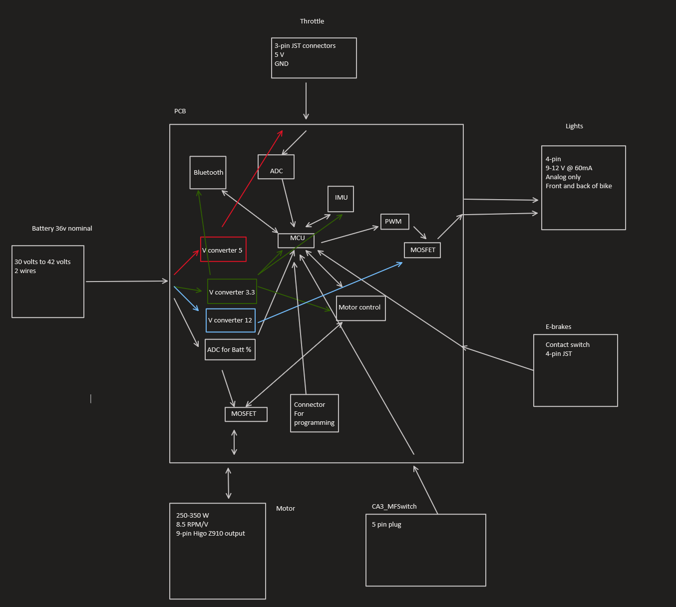

[Place holder for PCB]

## 5.2 Schematics

**MCU**

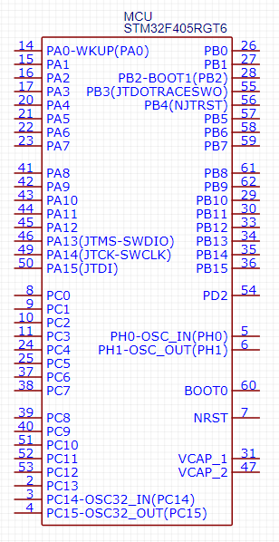

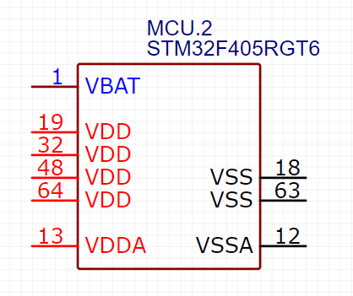

The two the schematics are for the MCU we will be using.

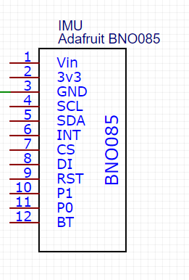

Above is the schematic for the IMU that may be put onto the PCB

**Bluetooth module**

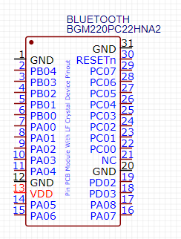

Above is the schematic for the Bluetooth that we will be using.

**Driver**

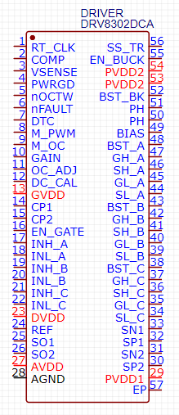

Above is the schematic for the drive controller we will be using.

**DC/DC 12 volts @2A max volts for the lights**

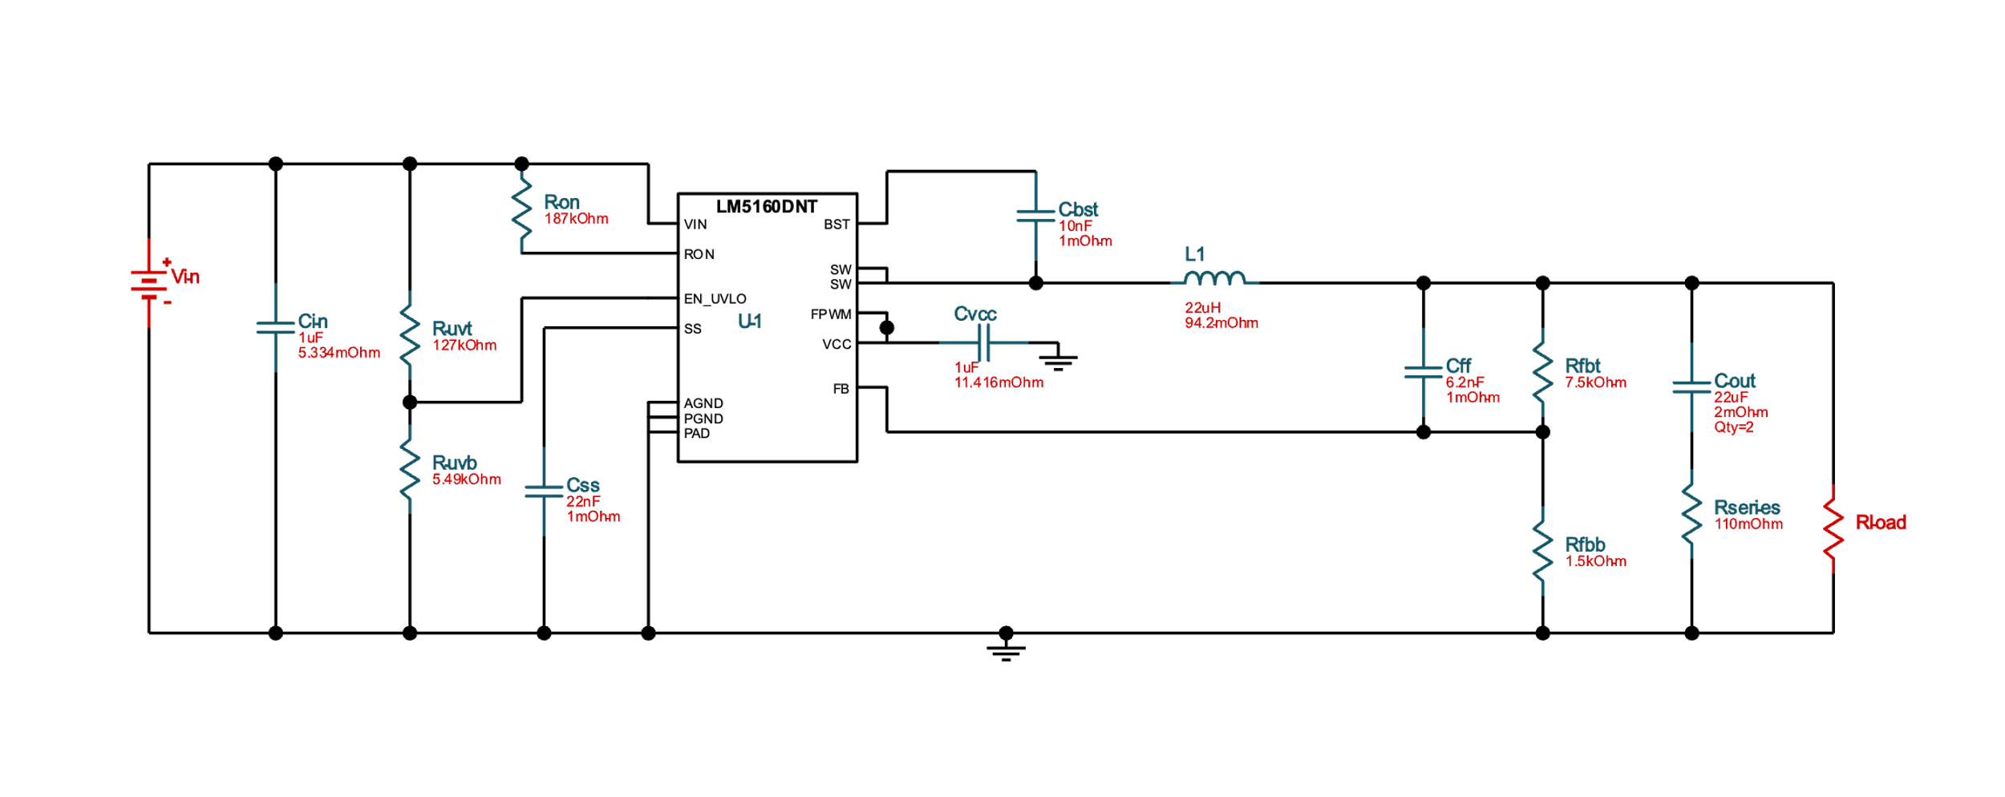

The lights will require MOSFET to power and an optional PWM for color changing. This will allow us to have different colors for the front and back. Like brake lights and a headlight for the front.

**DC/DC 5 volts for throttle**

**DC/DC 3.3 volts @ 85mA max for MCU, Bluetooth, IMU, and Motor control**

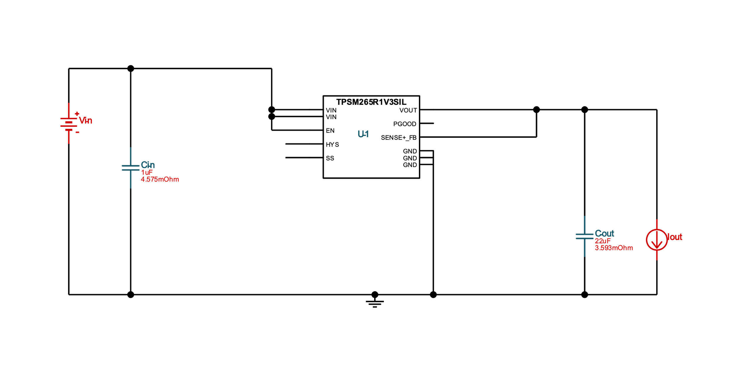

## 5.3 Software

The software required for this project to function can be found in two main places: the microcontroller unit (MCU) and the smartphone application being developed. The software in the MCU will handle the PCB operations: regulating speed, Bluetooth connection, etc. The software found in the smartphone application will be dedicated to just that: the app. The application and the PCB will communicate via Bluetooth and will be capable of sending/receiving information to and from the e-bike.

### 5.3.1 MCU Software Design

### 5.3.2 Application Software Design

### 

This section will go into detail about the structure of the smartphone application and its functions. The current build of the application works as intended on both platforms: iOS and Android. Screenshots are provided for visual aid. Even though the application works on both platforms, the provided screenshots are currently only from the iOS simulator to reduce image clutter.

### 5.3.2.1 Landing Page/Use Warning

The working design for the application is currently as follows: when running the application on the operator’s smartphone, after it is finished loading, it will open to a home landing page with different features listed. The group has plans to develop this landing page as a directory; it will feature labeled icons that, when interacted with, will direct the user to different pages/screens on the application. Currently, the group has plans to create a Bluetooth connectivity icon and a heads-up-display (HUD) icon.

Before the user can interact with the application, however, they are brought to a warning screen conveying the following message:

**“****WARNING:**

**Using this application while operating the e-bike is strongly disadvised.**

**While it is not illegal, it puts not only yourself in danger, but also those around you.**

**If currently operating e-bike, please come to a complete stop before continuing.**

**Thank you for your cooperation.”**

This message will be formatted and worded precisely as it is above. As mentioned in the message: it is not currently illegal to operate an e-bike and use a smartphone. However, it is strongly advised against due to the smartphone’s nature to distract the e-bike operator. The group believes this message is entirely necessary to take steps to prevent operator harm or danger. At the bottom of this message is a button for the user to interact with that confirms that they are, in fact, not in motion. Only after the user confirms there are not in motion via this button will they be able to access the application and its features. Screenshots of the warning message screen and the home landing page are provided below.

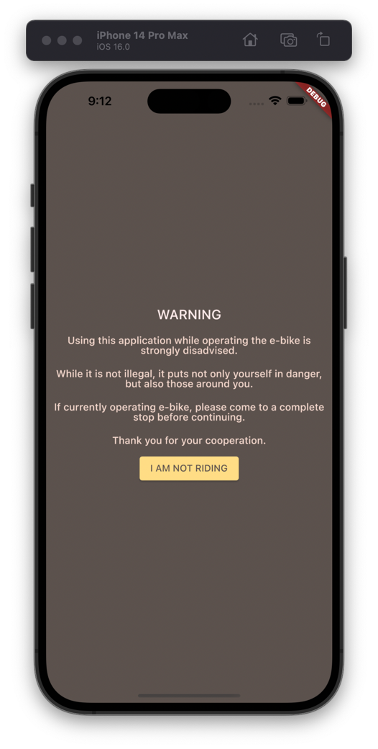

Figure : The warning page the app opens to

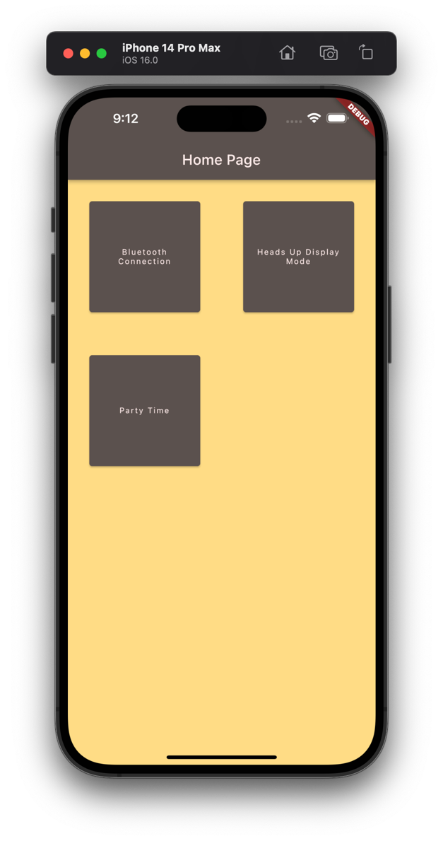

Figure : The home page of the app

It should be noted that the “Party Time” button currently has no function. Its purpose is to add visual support for how the icons are currently arranged and, if any other features are planned, how future icons can be added/organized on the home screen.

### 5.3.2.2 Bluetooth Connectivity Page

The Bluetooth connectivity page will be the first page open provided on the home page (as shown in the screenshots provided in the previous section). It will contain features to check on, maintain, and test the Bluetooth connection between the smartphone and the e-bike. This page is being planned to feature a window that will inform the user of the status of the current Bluetooth connection with the e-bike. This page will also feature a button that, when pressed, will direct the user to the smartphone’s Bluetooth settings. Below this button will be instructions on how to connect to the e-bike within the platform’s specific settings.

There are also currently plans to implement an interaction on this screen that, when interacted with, will confirm the Bluetooth’s connection with the e-bike by changing something on the e-bike itself. The current plan is to feature a button that, when pressed, will change the color of an LED on the e-bike’s main PCB.

A screenshot of the current work-in-progress prototype of the Bluetooth connectivity page provided below:

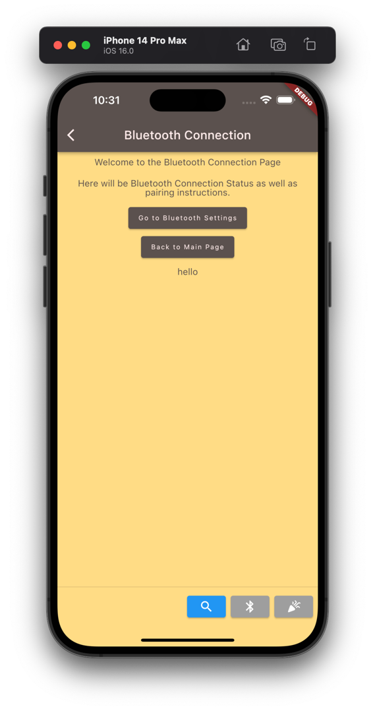

Figure : Prototype, WIP Bluetooth page

Currently, the “*Go to Bluetooth Settings*” button works correctly on both platforms and takes the user to their platform-respective Bluetooth settings page. The “*Back to Home*” button work as intended as well and sends the user back to the directory home/landing page.



Figure : The "Go to Bluetooth Settings" button in action

### 5.3.2.3 Heads-Up-Display Page

The second option on the home/landing page is the Heads-Up-Display (HUD) page. This page will be exactly what it is titled to be: a page that holds several widgets containing useful information to report to the operator of the e-bike. This page is a work-in-progress and is not complete, however navigating to the page itself is still possible in the current build of the application.

The widgets currently planned to be included on the HUD page are a speedometer, battery charge, and voltage output. There are plans to add more, if possible, but the group does not want to over-clutter this screen. Too many widgets would lead to distractions, which we would like to avoid with someone operating a vehicle.

## 6. Project Prototype Construction

### 6.1 Battery mounting

The battery pack came in two parts. The mounting bracket and the battery itself. The bracket will be mounted in front of the knees along the rim of the bike. Here are the included parts:

* Battery fix plate and part
* Battery and key
* Charger and AC wire
* Manual and qualified certificate

To install onto the bike, we will need to drill two holes into the frame of the bike then use the screws to secure the battery mount to the bike. The battery pack itself will be removable form the mount and has a key that is required to lock the battery pack onto the mount.

### 6.2 Motor Mounting

Parts included:

* G310 Hub Motor
* Axle Spacer Wash
* Tabbed Washers (2)
* M10 Washers (2)
* Acorn Nuts (2)

1. If the bike has disc brakes, install the disc rotor; in this case, make careful to remove the disc rotor spacer.
2. On the cable side, the hardware is arranged as follows: tabbed washer, dropout, M10 washer, and acorn nut. Make that the motor and tabbed washer are positioned such that the cable emerges downward. Water intrusion may occur if the wire is oriented upward.
3. The hardware is installed in the following order on the non-cable side: axle spacer washer, tabbed washer, dropout, M10 washer, and acorn nut.
4. Once the hardware is in place and the engine is mounted in the dropouts, tighten the axle nuts to 40Nm (30 ft-lb).

The Grin wheel builder will have dished the wheel presuming the addition of the axle spacer washer on the cassette side if the motor was purchased from Grin pre-laced. Otherwise, if we were doing the wheel build ourselves, we would need to be aware that adding this axle spacer (as needed for wider 9-11 speed cassettes) will have a modest impact on the correct dishing of the wheel, comparable to half the width of the spacer (0.75mm or 1/32").

### 6.3 RGB LED Strip Wiring

1. It's quite simple to connect to the strip; you only need to solder four wires to the copper tabs. Red, green, and blue wires will be used for the matching LED colors, with white used for +12V.
2. Trim off the waterproof over molding at the strip's end. There is no right or wrong end to utilize because the strips are symmetrical.
3. To reveal the copper pads, scrape off the rubber. To tin the pads and burn off any remaining rubber, melt some solder onto them.
4. Glue the four wires together. Wire that is more flexible and likely a better option than solid core is the kind we utilized.
5. Use heat shrink to shield the wires and keep some waterproofness.

We can easily utilize any microcontroller with these LED strips because they are so straightforward. To regulate the strip, we advise using PWM dimming methods. Power transistors are needed since each "LED" pin can end up needing an amp or more to get to ground. Avoid trying to connect the pins directly to the microcontroller; we are at risk of having them burn out or malfunction. We can use any power NPN or N-Channel MOSFET, but make sure it is rated to carry as much current required. As we typically draw 0.2 Amps per channel per meter, for instance, a 5 meter strip would require passing up to 1 Ampere each transistor.

## 7. Project Prototype Testing Plan

In this section of the report, we will be explaining the different ways in which we will be conducting the testing phase. The goal of this section is for us to test the system and make sure that all parts are communicating due to proper integration. Also, with aiding us in making sure we can locate any errors and make the appropriate fixes that need to be made. The testing phase will subject our design to different tests in both hardware and software. For example, we would want to app to display the speed and battery life of the bike. So, we would need to make sure that the microcontroller and Bluetooth module is communicating appropriately. Then the Bluetooth module would then be able to communicate with any device that is connected to it. Essentially, any tests that are conducted to any of the physical parts on the PCB will be considered hardware and anything else such as the application that we are creating is considered software.

### 7.1 Hardware (Carlos and Alex)

|  |
| --- |
| **Tools for Testing** |
| Hantek 2D42 |
| Digilent Ultra Analog Discovery 2 Bundle |
| Windows PC |
| Bluetooth enabled device |
| BK precision 2860 |

Every engineering project needs to include a stage for testing operational hardware. Regardless of where a product comes from, it is essentially meaningless without a comprehensive testing. Such rigorous testing and quality control techniques are used by the most reputable and regarded businesses, producers, and university inventors. The challenging testing and endorsement that those experts consider in their decision-making processes are influenced by a number of elements, but this project was designed and created by us senior level engineering students. Nonetheless the proper testing procedures must be taken into count in order to have product with minimal to no problems.

### 7.1.1 Test Environment

The design will need to be able to use a power source that runs between 30 to 42 volts and have the ability to recharge. With this we would need to pick a battery that can pass any environmental or safety issues. Having a gadget undergo automated discharge cycles will help maintain battery life since people are less likely to totally deplete rechargeable batteries before recharging. More than enough power is produced by the rechargeable batteries to support the entire circuit. Delivering adequate electricity to every component of the system is the goal. To achieve optimal efficiency, the converter we are adopting is based on a pulse width-modulation (PWM) controller. The converter enters power-saving mode at low load currents to maintain high efficiency over a range of load current. As a result, the device's components are all appropriately powered.

### 7.1.2 Durability

The most crucial testing for this project will take place in various weather scenarios. Given that the consumer will want to use this item almost everywhere (most frequently outside while cycling), the weather must be taken into account while considering this. The tool must be resilient to the majority of weather scenarios. We will test our powered tracking device's capacity to function even in the wettest of weather circumstances because if it can't, it won't be able to withstand those types of conditions for very long, which won't be good for us. For these kinds of circumstances, we must complete our design so that we won't be late on the day of the presentation. What kind of material will work best for our testing needs to be considered when doing this durability test.

This project's dependability and performance during our step-by-step construction process will demonstrate to us how well the project will hold up over time. We will be able to determine when our durability testing is complete whether or not our project is reliable enough to be used in the real world. The biggest concern at the moment is if our project's overall cost since we are funding it ourselves and for us to meet deadline. As the quantity of money we have will impact the types of materials we may buy, the time frame is another factor that will affect the project's durability.

### 7.2 Software (Victor and Chris)

## 8. Project Summary

# Work Cited

* “The Federal Register,” *Federal Register :: Request Access*. [Online]. Available: https://www.ecfr.gov/current/title-16/chapter-II/subchapter-C/part-1512?toc=1. [Accessed: 23-Mar-2023].
* A. Schirn, “ISO 4210-2:2023 - city, trekking, Mountain & Racing Bicycles - ANSI BLOG,” *The ANSI Blog*, 26-Jan-2023. [Online]. Available: https://blog.ansi.org/iso-4210-2-2023-trekking-mountain-racing-bicycles/?amp=1. [Accessed: 23-Mar-2023].
* A. Wang, S. Kadam, H. Li, S. Shi, and Y. Qi, “Review on modeling of the anode solid electrolyte interphase (SEI) for Lithium-Ion Batteries,” *Nature News*, 26-Mar-2018. [Online]. Available: https://www.nature.com/articles/s41524-018-0064-0#:~:text=A%20passivation%20layer%20called%20the,and%20ensure%20continued%20electrochemical%20reactions. [Accessed: 23-Mar-2023].
* B. Kelechava, “ANSI/ESD S20.20-2021: Protection of Electrical and Electronic Parts - ANSI Blog,” *The ANSI Blog*, 10-Jan-2023. [Online]. Available: https://blog.ansi.org/ansi-esd-s20-20-2021-protection-electronic-parts/. [Accessed: 24-Mar-2023].
* “ARM Programming - SparkFun Learn,” *learn.sparkfun.com*. https://learn.sparkfun.com/tutorials/arm-programming/jtag-and-swd (accessed Mar. 24, 2023).
* “Batteries,” *U.S. Consumer Product Safety Commission*. [Online]. Available: https://www.cpsc.gov/Regulations-Laws--Standards/Voluntary-Standards/Topics/Batteries. [Accessed: 23-Mar-2023].
* C. Pao, “The importance of IMU Motion Sensors - CEVA’s Experts blog,” *CEVA’s Experts blog*, Nov. 15, 2018. https://www.ceva-dsp.com/ourblog/what-is-an-imu-sensor/
* “The Federal Register,” *Federal Register :: Request Access*, 2015. [Online]. Available: https://www.ecfr.gov/current/title-30/chapter-I/subchapter-O/part-74/subpart-C/section-74.7. [Accessed: 23-Mar-2023].
* R. T. Corporation, “Li-ion battery and gauge introduction,” *Li-ion Battery and Gauge Introduction | Richtek Technology*. [Online]. Available: https://www.richtek.com/Design%20Support/Technical%20Document/AN024. [Accessed: 23-Mar-2023].
* “UL 2272 and the safety of personal e-mobility devices,” *UL solutions*, 2016. [Online]. Available: https://collateral-library-production.s3.amazonaws.com/uploads/asset_file/attachment/12042/10414_HoverboardSafety_V2R6_FINAL.pdf. [Accessed: 23-Mar-2023].
* “The Federal Register,” *Federal Register :: Request Access*. [Online]. Available: https://www.ecfr.gov/current/title-49/subtitle-A/part-37/subpart-A/section-37.3. [Accessed: 23-Mar-2023].
* “U.S. Energy Information Administration - EIA - independent statistics and analysis,” *Use of gasoline - U.S. Energy Information Administration (EIA)*. [Online]. Available: https://www.eia.gov/energyexplained/gasoline/use-of-gasoline.php. [Accessed: 23-Mar-2023].
* “Learn about the different ways heading (azimuth) is determined · VectorNav,” *www.vectornav.com*. https://www.vectornav.com/resources/inertial-navigation-primer/theory-of-operation/theory-heading (accessed Mar. 24, 2023).
* “Lithium-Ion Battery Standards: Energy,” *U.S. Agency for International Development*, 21-Mar-2023. [Online]. Available: https://www.usaid.gov/energy/powering-health/technical-standards/lithium-ion-batteries. [Accessed: 23-Mar-2023].
* Person and S. D. David Shepardson, “U.S. driving soars in 2021 to 3.23 Trillion Miles, up 11.2%,” *Reuters*, 18-Feb-2022. [Online]. Available: https://www.reuters.com/world/us/us-driving-soars-2021-up-112-2021-2022-02-18/. [Accessed: 23-Mar-2023].
* M. Timmons, “Car ownership statistics in the U.S.,” *ValuePenguin*, 17-Aug-2022. [Online]. Available: https://www.valuepenguin.com/auto-insurance/car-ownership-statistics. [Accessed: 23-Mar-2023].
* “AN957 sensored BLDC motor control using DSPIC30F2010 - Microchip Technology.” [Online]. Available: https://ww1.microchip.com/downloads/aemDocuments/documents/OTH/ApplicationNotes/ApplicationNotes/BLDCMC00957a.pdf. [Accessed: 24-Mar-2023].
* Cythinay, Rick, Ahmed, W. Vieira, and Dejan, “How Brushless DC Motor Works? BLDC and ESC explained,” How To Mechatronics, 16-Nov-2022. [Online]. Available: https://howtomechatronics.com/how-it-works/how-brushless-motor-and-esc-work/. [Accessed: 23-Mar-2023].
* “Differences Among Arm® Cortex® Families - Developer Help,” *microchipdeveloper.com*. https://microchipdeveloper.com/32arm:differences-among-arm-cortex-families (accessed Mar. 24, 2023).
* “Grin tech torque arm info page,” *ebikes.ca*. [Online]. Available: https://ebikes.ca/product-info/grin-products/torque-arms.html. [Accessed: 23-Mar-2023].
* “Gyro sensors - How they work and what’s ahead | about Gyro sensor | Technical Information | other Information,” *Epsondevice.com*, 2019. https://www5.epsondevice.com/en/information/technical_info/gyro/
* “Highlights of the Automotive Trends Report,” *EPA*. [Online]. Available: https://www.epa.gov/automotive-trends/highlights-automotive-trends-report. [Accessed: 23-Mar-2023].
* “Hub Motors - Learn,” *ebikes.ca*. [Online]. Available: https://ebikes.ca/learn/hub-motors.html. [Accessed: 23-Mar-2023].
* “Summary of Ebike components - learn,” *ebikes.ca*. [Online]. Available: https://ebikes.ca/learn/summary-of-ebike-components.html. [Accessed: 23-Mar-2023].
* “Highlights of the Automotive Trends Report,” *EPA*. [Online]. Available: https://www.epa.gov/automotive-trends/highlights-automotive-trends-report. [Accessed: 23-Mar-2023].
* “Introduction to MEMS Accelerometers,” *Pcb.com*, 2013. https://www.pcb.com/resources/technical-information/mems-accelerometers
* “5 major differences between IOS and Android App Development,” *EGO Creative Innovations - we design apps that your users love*. [Online]. Available: https://www.ego-cms.com/post/5-major-differences-between-ios-and-android-app-development. [Accessed: 23-Mar-2023].
* B. L. E. M. Apps, “Top 5 Factors to Consider When Choosing Bluetooth Module,” *BLEMobileApps*, 11-Sep-2020. [Online]. Available: https://www.blemobileapps.com/blog/top-5-factors-to-consider-when-choosing-bluetooth-module/. [Accessed: 23-Mar-2023].
* “Express/node introduction - learn web development: MDN,” *Learn web development | MDN*. [Online]. Available: https://developer.mozilla.org/en-US/docs/Learn/Server-side/Express_Nodejs/Introduction. [Accessed: 23-Mar-2023].
* “Flutter app backend: The Best Five Providers,” *Back4App Blog*, 22-Aug-2022. [Online]. Available: https://blog.back4app.com/flutter-app-backend/. [Accessed: 23-Mar-2023].
* M. (N/A), “Which Type of Electric Bicycle Throttle Is Best?,” *EbikeSchoolcom*. [Online]. Available: https://www.ebikeschool.com/type-electric-bicycle-throttle-best. [Accessed: 23-Mar-2023].
* M. Li, “Complete Guide on Bluetooth Bodule,” *MOKOBlue*, 20-Aug-2021. [Online]. Available: https://www.mokoblue.com/complete-guide-on-bluetooth-module. [Accessed: 23-Mar-2023].
* “Pedal assist or throttle controls,” *Juiced Bikes*. [Online]. Available: https://www.juicedbikes.com/pages/chapter-5-pedal-assist-or-throttle-control. [Accessed: 23-Mar-2023].
* Person, “LED vs. Regular Lightbulbs: Do they really make a difference?,” *Blog*, 16-Mar-2020. [Online]. Available: https://blog.arcadia.com/led-vs-regular-lightbulbs-do-they-really-make-a-difference. [Accessed: 23-Mar-2023].
* S. L. Staff, “Lighting comparison: LED vs Incandescent Lighting,” *LED Lighting Distributor and Implementation Company*, 21-Apr-2016. [Online]. Available: https://www.stouchlighting.com/blog/light-comparison-led-lighting-vs-incandescent-lighting. [Accessed: 23-Mar-2023].
* “Silicon Sensing | MEMS Accelerometers,” *www.siliconsensing.com*. https://www.siliconsensing.com/technology/mems-accelerometers/
* “The Piezoelectric Effect - Piezoelectric Motors & Motion Systems,” *NANOMOTION*. https://www.nanomotion.com/nanomotion-technology/the-piezoelectric-effect (accessed Mar. 24, 2023).
* “Types of Lighting: Incandescent Bulbs,” *Types of Lighting: Incandescent Bulbs | EGEE 102: Energy Conservation and Environmental Protection*. [Online]. Available: https://www.e-education.psu.edu/egee102/node/2035. [Accessed: 23-Mar-2023].
* omega, “Accelerometers & How to Measure Acceleration,” *https://www.omega.com/en-us/*, Aug. 28, 2018. https://www.omega.com/en-us/resources/accelerometers
* “VESC Project,” *vesc-project.com*. https://vesc-project.com/
* “What is a LAMP Stack?,” *Amazon*, 1978. [Online]. Available: https://aws.amazon.com/what-is/lamp-stack. [Accessed: 23-Mar-2023].
* “Which ARM Cortex Core Is Right for Your Application: A, R or M?” Available: https://www.silabs.com/documents/public/white-papers/Which-ARM-Cortex-Core-Is-Right-for-Your-Application.pdf